Oxford Reading Tree

Stage 7 Resources

Contents …

- The Red Planet
- The Lost Key

Name:
The word race has a magic ‘e’ on the end of it. The ‘e’ changes the sound of the vowel ‘a’. It makes it say its letter name ‘a’ rather than its sound ‘ah’. Say the words below to hear the difference.

race fast
Look through a ‘The Red Planet. Find as many magic e words as you can in the story.
- Write the page number beside each word.

Eg. made – page 1

______________________________________________________________________________________________________________________________________________________________________________________________________________________________________________________________________________________________________________________________________________________________________________________________________________________________________________

Fill in the rest of the sentences to answer the questions.
Remember to add full stops at the end of each sentence.

1. What did the children make the rocket ship out of? [page 1]

The children made _____________________________________
_____________________________________

2. Why did the children decide to go inside? [page 5]

_______________________________________
______________________________________________________________________________
_______________________________________

3. Describe the red planet. [page 15]

_______________________________________
_____________________________________________________________________________________________________________________

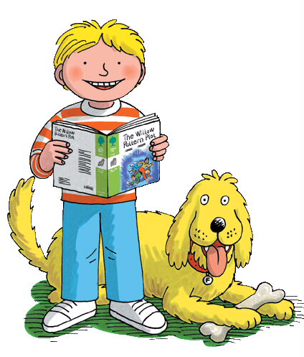
Now read the sentences to make sure they make sense.
Nano nano! I forgot to add capital letters and full stops! Write out the sentences below with capital letters and full stops so that they are easy to read. There are 2 sentences in each question.

Name:

1. they wanted to go outside and look at the planet they found a space buggy
__________________________________
____________________________________________________________________

2. suddenly the ground cracked and a big hole opened up the buggy fell in the hole
__________________________________
__________________________________________________________________________________________

3. they all landed with a bump the buggy landed with a crash and broke in two
_______________________________________________________________________________________________________________________________________
__________________________________________________________________________________________________________________________________________________________________________________________________________________________________________________________________________________________________________________________________________________________________________________________________________

You go on your own adventure. You encounter some aliens. Draw what they look like below and write verbs to tell me how they move and what they do.

The Lost Key
Name:

Fill in the gaps.

1. Kipper put the magic key in his ______________.
2. When he was running to the __________ the key fell out.
3. The ___________ ran over the key with a ___________.
4. The key _________ the glass of the greenhouse.
5. Kipper saw the key inside a _____________ picture.
6. The children ____________ the key from the picture and _______________ off the paint.
7. _____________ thought of a good idea.
fault rubbed pocket

pulled little rocket broke

mower clang
7. “It’s all my ______________!” cried Kipper.
Fill in the words to find out who had a good idea in the story.

1
2
3
4
5
6
7
1. Mum took Kipper shopping for new _ _ _ _ _ _ _ _. [page 2]

2. The children went to the _ _ _ _ shop to look for the key. [page 16]

3. Biff and Chip gave Mum their pocket _ _ _ _ _. [page 23]

4. “It’s a lot to pay for an old _ _ _,” said Mum. [page23]

5. “It’s had a bad _ _ _ _,” said Wilma. [page 25]

6. One boy tied the key to a piece of _ _ _ _ _ _. [page 9]

7. Suddenly the _ _ _ _ _ key began to glow. [page 32]

