The Marvellous, Mighty, Monster Truck!
50% OFF FOR A LIMITED TIME!

HURRY! WHILE STOCKS LAST!
VOTED BEST TOY OF 2014

Children, are you fed up with your toys breaking?
Are you looking for a new fantastic unbreakable monster truck?
Well look no further, help is here with the indestructible, Marvellous, Mighty, Monster Truck here just for YOU!
The Mighty Monster truck is like no other truck that has ever been seen before!
It has an all-new exceptional and electrifying design! This toy for YOU; it will be a superb, special and sensational addition to YOUR toy collection!
The Mighty Monster truck has many breakthrough and breathtaking features including:
- It’s mind-bogglingly huge wheels (monster truck will be able to go everywhere YOU go),
- Remarkably responsive, smooth suspension, (so your monster truck will not be damaged by any bumps),
- An everlasting body kit made out of robust rubber, (so your monster truck can survive any collision that may occur),
- Remarkable voice recognition technology, (which allows you to control your monster truck by telling it were you want it to go as it responds to 25 programmable commands),
- Incredibly interesting and entertaining, (your monster truck will keep you entertained for hours and hours and will make you popular with your friends!)
Let the Marvellous, Mighty, Monster Truck join your toy box today and you’ll have the privilege of owning the most amazingly mind-blowing Monster Truck there ever will be!
Miss it! Miss out!
The Mighty Monster Truck can be purchased from Toy world Ltd for the small price of just £199.99 from 2014. Prices may vary according to the detail wanted. See in-store for details. Why not come and try the Mighty Monster Truck for yourself at one of the stores? Book today, call 08867, 156345!
THE EGG-CELLENT EASTER CHICK-A-CHOC.

VOTED BEST EASTER GIFT OF 2014!
HURRY! WHILE STOCKS LAST!

ARE YOU LOOKING FOR A SUPER SPECIAL EASTER GIFT?
Want to buy something eggs-tra special this Easter?
Well look no further, help is here with the amazing new, EGG-CELLENT EASTER CHICK-A-CHOC here just for YOU! The EASTER CHICK-A-CHOC is like no other gift that you have ever been given before!
Each EASTER CHICK-A-CHOC includes an all-new, deeply, delicious chocolaty recipe AND your very own adorable Easter chick that hatches out of a chocolate egg! This eggs-tra-ordinary gift is available for YOU; just imagine receiving this special and sensational gift on Easter Day!
The EASTER CHICK-A-CHOC uses many breakthrough technologies including:
- Chick-cam technology – hook up your EASTER CHICK your PC, Mac, Tablet or Smart Phone and it will amaze and amuse your friends!
- Remarkably cute, fluffy and silky smooth - so your EASTER CHICK looks and feels like a live, newly hatched chick!
- The taste of chocolate heaven - your edible EASTER CHICK-A-CHOC egg is made from the most delicious, delectable dark and milk chocolate!
- Remarkable voice recognition technology - which allows you to communicate your EASTER CHICK by giving it voice commands as it responds to 25 programmable commands.
- Incredibly interesting and entertaining - your EASTER CHICK-A-CHOC will keep you entertained for hours and hours and will make you popular, particularly with your friends!
Get the EGG-CELLENT EASTER CHICK-A-CHOC this Easter and you’ll have the privilege of owning the most amazingly mind-blowing Easter gifts there has ever been!
M.I.M.O
The EASTER CHICK-A-CHOC can be purchased from Chocolate world Ltd for the small price of just £39.99 from 2014. Prices may vary according to the detail wanted. See in-store for details. Why not come and see the EASTER CHICK-A-CHOC for yourself at one of the stores? Book today, call 08867, 156345!
Wonderful Walle™ Helping Hand.
THE AMAZING LIFE-SIZED ROBOT!
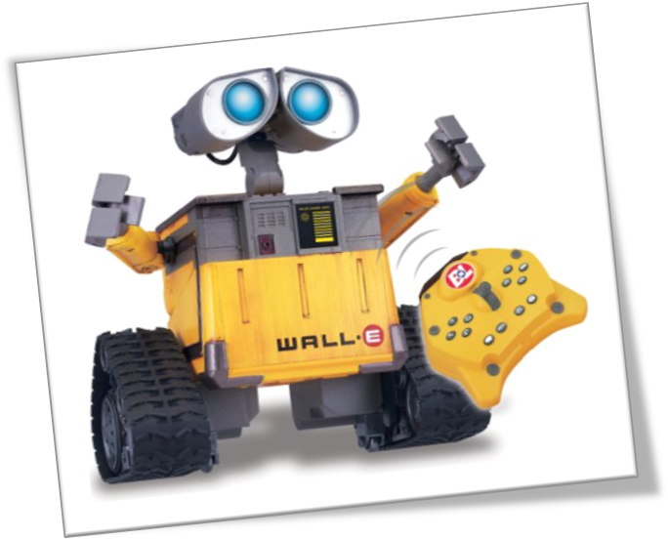
VOTED BEST TOY OF 2014
REAL LIFE – SIZED WALLE!

Children, are you looking for a toy with more personality?
Are you looking for a new fantastic remote controlled helper around the house?
Well look no further, help is here with the incredible, Wonderful Walle™ Remote Controlled Helping Hand here just for YOU!
The Walle™ Helping Hand ™ is like no other robot that has ever been made before!
It has an all-new exclusive and electrifying design! This toy for YOU; it will be a superb, special and sensational addition to YOUR toy collection and it will help you with your chores!
The Walle™ Helping Hand ™ has many breakthrough and exclusive features including:
- It’s mind-bogglingly big wheels (Walle will be able to go everywhere YOU go).
- Remarkably responsive, proximity sensors, (so your Walle will not be bumping into any walls!).
- An everlasting body kit made out of robust rubber, (so your Walle can survive any collision that may occur).
- Remarkable voice recognition technology, (which allows you to control your Walle by telling it what you want it to do - it responds to 25 programmable commands).
- Incredibly interesting and entertaining, (your Walle will keep you entertained for hours and hours and will make you popular with your friends!).
Let the Marvellous, Walle™ Helping Hand join your toy box today and you’ll have the privilege of owning the most amazingly mind-blowing Robots- EVER!
The Walle Helping Hand can be purchased from Toy world Ltd for the small price of just £199.99 from 2012. Prices may vary according to the detail wanted. See in-store for details. Why not come and try Walle Helping Hand for yourself at one of the stores? Book today, call 08867 156345!

