*** Plurals of words ending in 'f', 'ff' and 'fe'
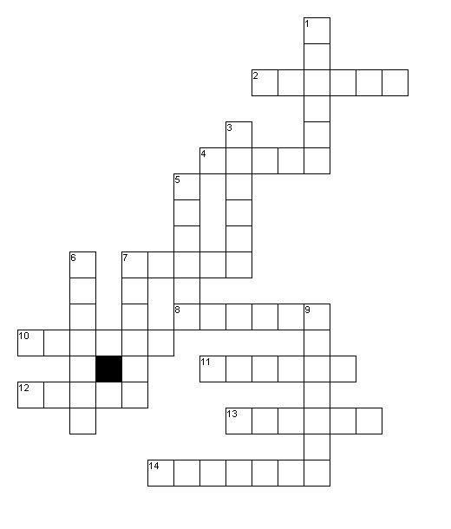
Across
2. Plural of half
4. Plural of reef
7. Plural of cuff
8. Plural of sniff
10. Plural of knife
11. Plural of loaf
12. Plural of puff
13. Plural of calf
14. Plural of thief
Down
1. Plural of wolf
3. Plural of leaf
5. Plural of cliff
6. Plural of belief
7. Plural of chief
9. Plural of shelf
** Plurals of words ending in 'f', 'ff' and 'fe'

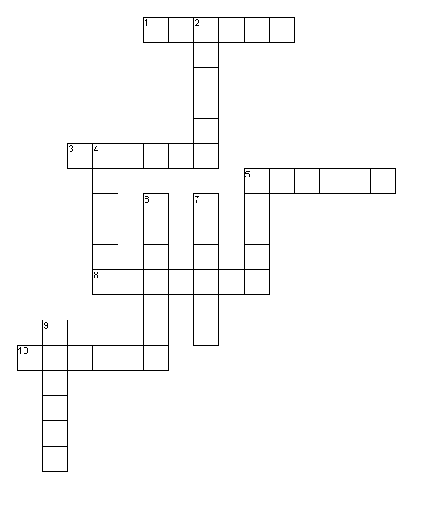

Across
1. Plural of wolf
3. Plural of cliff
5. Plural of chief
8. Plural of shelf
10. Plural of calf
Down
2. Plural of loaf
4. Plural of leaf
5. Plural of cuff
6. Plural of thief
7. Plural of knife
9. Plural of half

* Plurals of 'f', 'ff' and 'fe' words

h a l v e s r l s f f u c w w
y x g n t e z h e t g h x q o
s x b j e h s s l a k r j x w
q w k f e h i s e o v f w o s
d s s l e x y e f v a e i r i
u y w l z i z a v e l v s z d
h w v s e v l o w e i a e h e
r e b e l i e f s s s h c s k
s t n m z r j n f a f k c m o
o e d w v y s g i k t f k m p
c l i f f s e p e t d w u s c
l j j t s c v s f f i n s p s
m t q o y p i o p j r j d j g
h v d s t b n v s u i f a t b
n z l i q a k k i l p f q l a

beliefs  calves  chiefs  cliffs  cuffs  halves  knives  leaves | loaves  puffs  reefs  shelves  sniffs  thieves  wolves

