Beds

My bed is wooden,
Your bed is too, 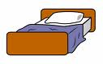
His bed is purple,
Her bed is blue,
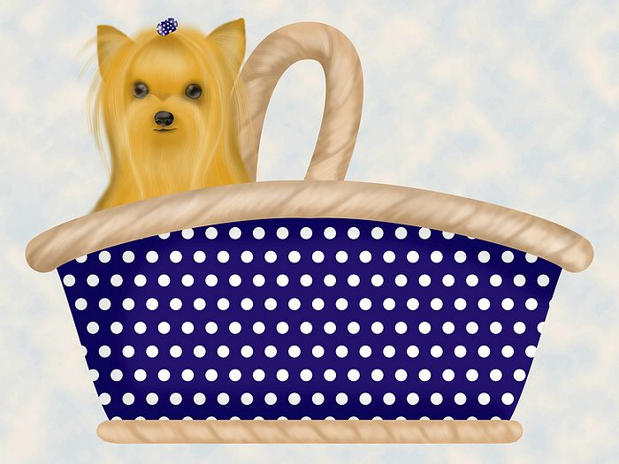
Its bed is a basket,
Our beds make a pair,
Your beds are all bunk beds,
Their beds are the air.
Catherine Leyow

