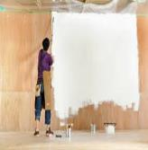 |  |  | 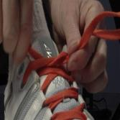 |  |  |  |  |  | 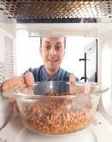 |  | 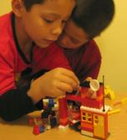
Stick the word
Write the word
re | re | re |  | re |  | re | re | paint | tie | build
tell |  | heat |  |  | make |  |  | Cut out and make the ‘re’ prefix words. Practise writing the words. Can you put them into a sentence?

