Name:_____________ Date:__________
Rumpelstiltskin
__________________________________________________________________________________________________________________________________________________________________________
__________________________________________________________________________________________________________________________________________________________________________

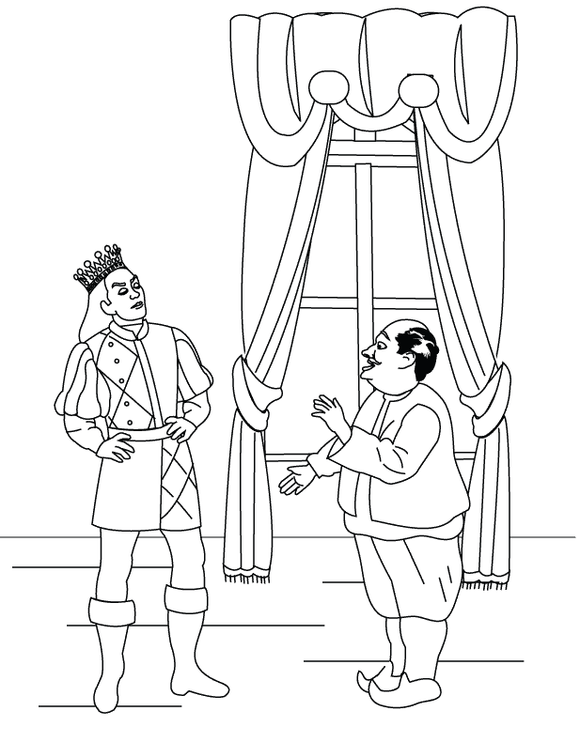
Name:_____________ Date:__________
Rumpelstiltskin
__________________________________________________________________________________________________________________________________________________________________________

__________________________________________________________________________________________________________________________________________________________________________

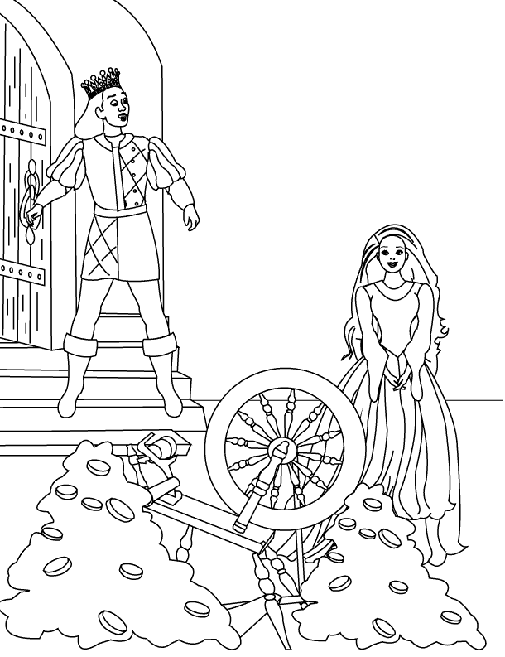
Name:_____________ Date:__________
Rumpelstiltskin
__________________________________________________________________________________________________________________________________________________________________________

__________________________________________________________________________________________________________________________________________________________________________

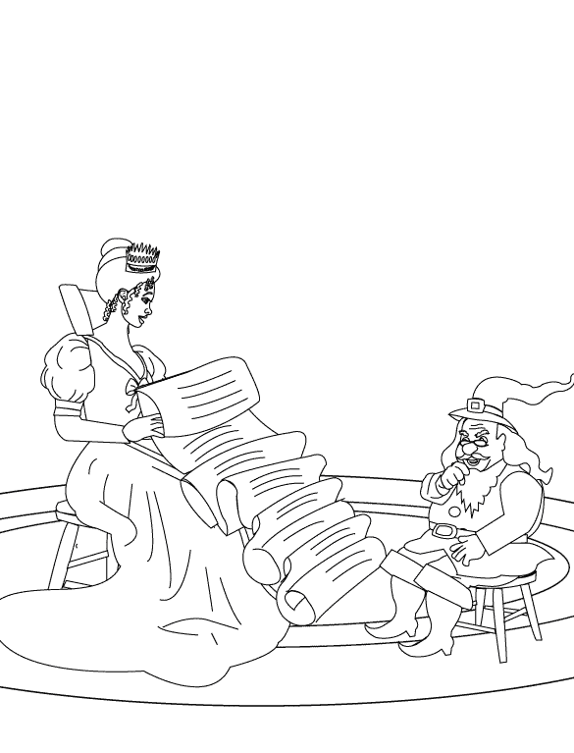

Name:_____________ Date:__________
Rumpelstiltskin
__________________________________________________________________________________________________________________________________________________________________________
__________________________________________________________________________________________________________________________________________________________________________

