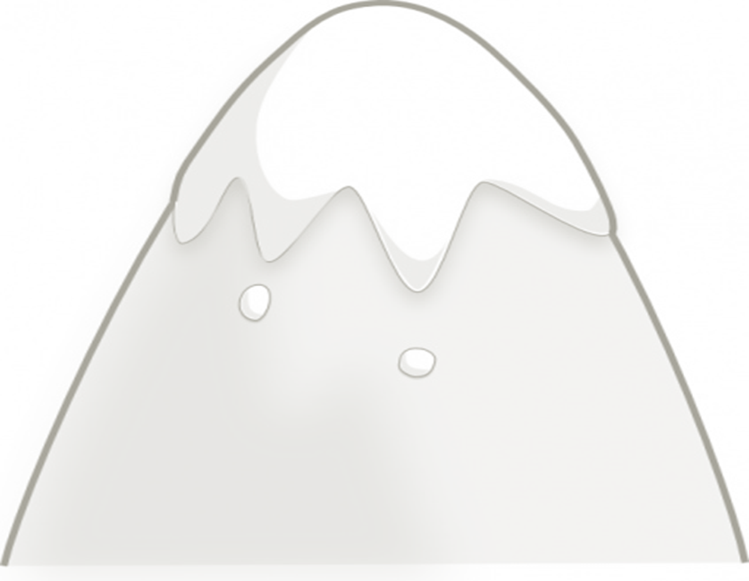
Story Mountain
Beginning:
Middle:
End:

