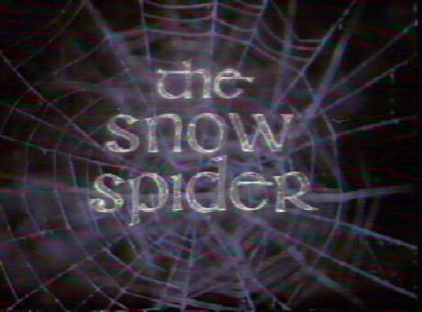

Chapter 1

1) Gwyn’s Gran is shown to be peculiar in the opening pages. Note 3 pieces of evidence to support this.

2) On pg 8 Gwyn’s father asked him 4 questions – Why didn’t Gwyn answer any of them?

3) Why was the yellow scarf so strange?

4) The author used the word chided on pg 14, what does it mean?

5) Pg 15 “We haven’t used it since” Since what? How do you know?

- What happened to Sión’s ear ?

- What do we know about Gwyn’s sister so far?

8) Why do Gwyn’s parents disagree about the party?

9) Which parent do you think is right? Why?

10) Do you agree that it’s Gwyn’s fault Bethan went missing?

11)How does the author hook us in the 1st chapter?

12) List all the questions you have after reading chapter 1.

Chapter 4

- Why was Gwyn so surprised Alun didn’t believe him at the start of the chapter?

- Why is Gwyn sad when Nain tells him the story about the day he was born?

- How did Gwyn know it was time for the seaweed?

- Why is Gwyn so confused by Pg 62?

- What do you think the last line of the chapter means?

- Is there one item that is likely to cause Gwyn a problem in the future?

- Can you tell what the following words mean by using the context of the text?

  - Distate pg 55
  - Unceremoniously pg 55
  - Precariously pg 58
  - Admonished pg 60

