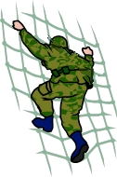
The soldiers on tour.
Eight soldiers are getting ready to go on a tour of duty. They have to pack lots of things into their kit bags.

The soldiers take:
shoe boot hanky sandwich
torch trainer camera hairbrush
shirt box glove scarf
penny dish knife address

Can you help the soldiers write a list to help them remember what they need to take? Because there are eight soldiers each item on the list needs to be plural (more than one). To make a word plural we change the ending by adding s, es or ies.
add s | add es | add ies

