We use ‘some’ and ‘no’ in affirmative sentences.
We’ve got some books.
We have no water.

We usually use ‘any’ in questions and negatives.
Have you got any money on you?
We haven’t got any water.
We can use ‘some’ in questions when we ask for permission or help, or when we expect the answer ‘yes’
Would you like some orange juice?
Can I have some orange juice, please?
Can I have something to drink, please?

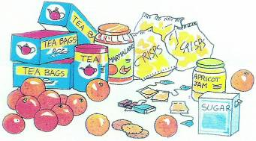

They’ve got ................................... sugar. (2 possibilities)They need ........................................ eggs.I can’t wait. I’ve got ............................... time.They’ve got ................................... water. (2 possibilities)Have they got ..................................... Coca-Cola ?There isn’t .................................... bread.Is there ............................... rice ?There’s .................................... spaghetti . (2 possibilities)Are there ................................ oranges ?There aren’t ............................... bananas.There’s ........................... cheese in the fridge. (2 possibilities)They haven’t got .................................. new clothes.It’s a nice hotel but there’s ............................... swimming pool.Would you like ................................................. coffee ?Can I have ............................... crisps, please ?He’s always alone. He’s got ............................. friends.Do you want ................................ biscuits with your tea ?I’m sorry, but there aren’t ............................ carrots here.Are there ........................... lions in Scotland ?There is ............................ park in this town. Has she got ............................. brothers or sisters ?He can’t buy a sandwich. He’s got ......................... money.There aren’t ................................ good hotels here.I can’t post this letter. I’ve got ............................. stamps.They haven’t got .................................. milk.

