Work Booklet –

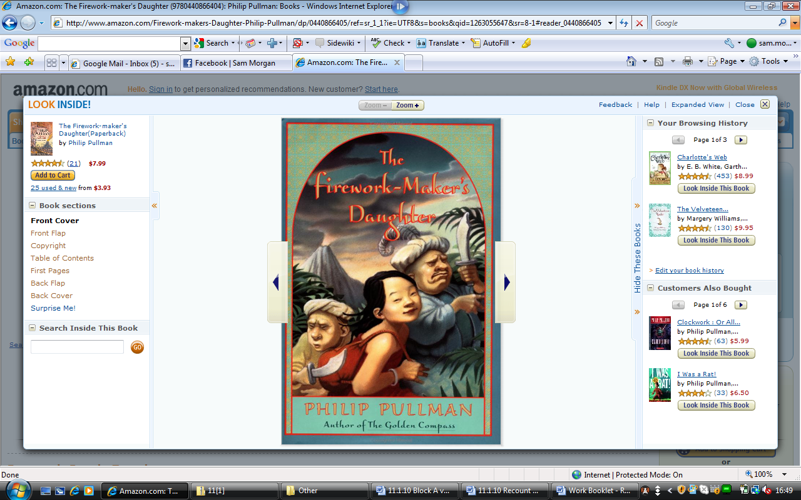
- Look carefully at the book cover, what do you think this book is going to be about? What kind of story do you expect it to be (i.e. crime, fantasy, sci-fi)? Why do you think this?

- Look back over the chapter you are reading. Can you select 5 powerful words that you could use in your own writing? Write them down.

- How do you think Lila felt when she found out that her Father wanted her to be a dancer? Write down how you think you would feel if you were Lila.

- Pick one of the fireworks mentioned in the first few pages of the book and draw a picture of how you imagine it to look when it explodes.

- Can you think of three slogans that could be written on the side of Hamlet, the White Elephant?

- Do you think Chulak should tell Lila the secret of becoming a true Firework-Maker? Consider your answer carefully, Chulak is Lila’s friend, but he promised Lalchand he would keep it a secret.

- At the end of page 18, Chulak asks Lalchand to find him some tarpaulin to help with the escape. Why do you think he wants tarpaulin? If you are unsure of what tarpaulin is, look it up in the dictionary.

- After finishing Chapter Two, draw a map of Lila’s journey so far. Make it as detailed as possible. The first page of the book will help you, along with some of Chapter Two.

- Do you think that the pirate Rambashi is the Uncle of Chulak? Give reasons for your answer.
- After reading about the Goddess, decide on ONE thing you would ask her for. Explain your reasons. You cannot ask her for ‘three more wishes!’

- Draw a cartoon strip of the main events of the story so far.

- Before reading Chapter Four, consider what you think Chulak will do now. What do you think he should do?

- After getting to the end of page 50, draw a picture of Lila. Around the outside of the picture, write down what you think she is feeling.

- Why do you think that Razvani laughed at Lila when she said she wanted to be a Firework-Maker?

- On page 62 Razvani says that everything in life, except change, is an illusion. What do you think he means?

- We have not yet been told what the ‘Three Gifts’ are. What do you think they could be?

- After reading Chapter Five, how do you think Lila feels when she learns her father is about to be executed?

- After reading page 73, what do you think Lila is going to do? Do you think she can win the competition? Why?

- Put yourself in either Lila or Lalchand’s position. Write a diary entry for the days leading up to the competition.

- If there had been a British Firework-Maker at the competition, what do you think his name would have been? Can you invent and describe a signature firework for him?

- Place yourself in Lila’s shoes. Junk write your about your feelings just after learning you’d won the competition.

- Now that you know what the three gifts are, do you think you could become Firework-Makers? Why/why not?

- Write a detailed book review. It should include:
- Why you liked/disliked the book;
- Some information about the main character;
- Information about the plot of the story;
- Relationships between characters;
- And, finally, would you recommend this book to a friend? Why/why not?

