UP LEVELLING IS TRYING TO IMPROVE A SIMPLE PIECE OF WRITING BY USING LOTS OF DIFFERENT METHODS - ADJECTIVES -ADVERBS -DESCRIPTIVE PHRASES - SIMILIES – METAPHORS - PERSONIFICATION - CONNECTIVES - CONJUNCTIONS - SENTENCE OPENERS - WIDE RANGE OF INTERESTING VOCABULARY …

This is based on ideas seen on a Ross Wilson course
Simple Passage To Be up Levelled by pupils

1. There was a little pond .
2. It was a hot day.
3. Along came a frog.
4. The frog hopped onto a Lily pad.
5. He fell asleep.
6. A heron was flying by.
7. He spotted the frog.
8. The bird dived down.
9. The sound woke the frog.
10. He moved out of the way.
11. The heron fell into the pond.
12. A pike was swimming by.
13 The fish opened her mouth.
14. She swallowed the bird.
15. On the riverbank was a fisherman.
16. In his hand was a fishing rod.

Up Levelled By Class 5

Hidden away at the bottom of the garden, was a crystal clear pond. The sun was beaming down onto the earth.

Out of the blue appeared a spotted frog. Clumsily, the pot bellied amphibian leapt onto the lily pad. Eventually he curled up, began to snore and dozed-off.

Soaring and swooping by, was an elegant heron. Out of the corner of his eye, he caught a glimpse of the chubby overweight frog.

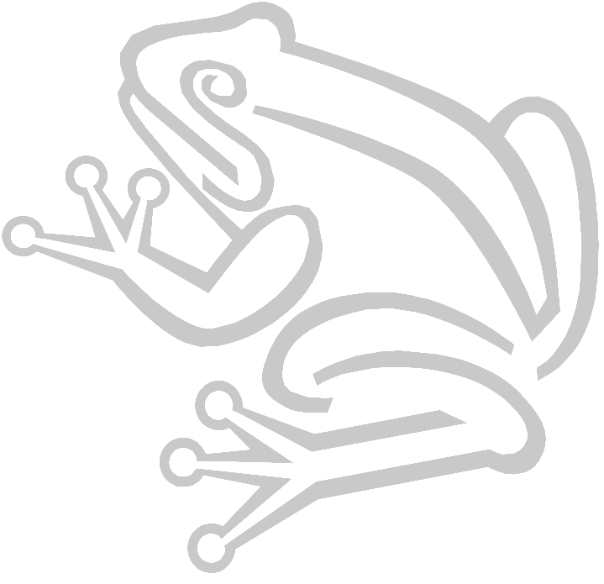
The confident bird plummeted down towards the glimmering waters. The loud screech disturbed the vulnerable frog. Leaping out of the way the spotted frog landed on the luscious green grass.

The silvery heron swooped into the glistening pond, just as a huge pike was frantically swimming by. The fierce fish opened her mouth and gulped down the silver bird.

Crouching on the river banking, a fat hairy fisherman was holding a huge rod and net. Will this be the pikes last meal???
