What is the first sound in these words?

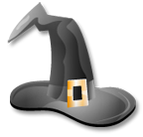
c t h p p b d w d r t b

g r d w c v s h q w c n

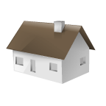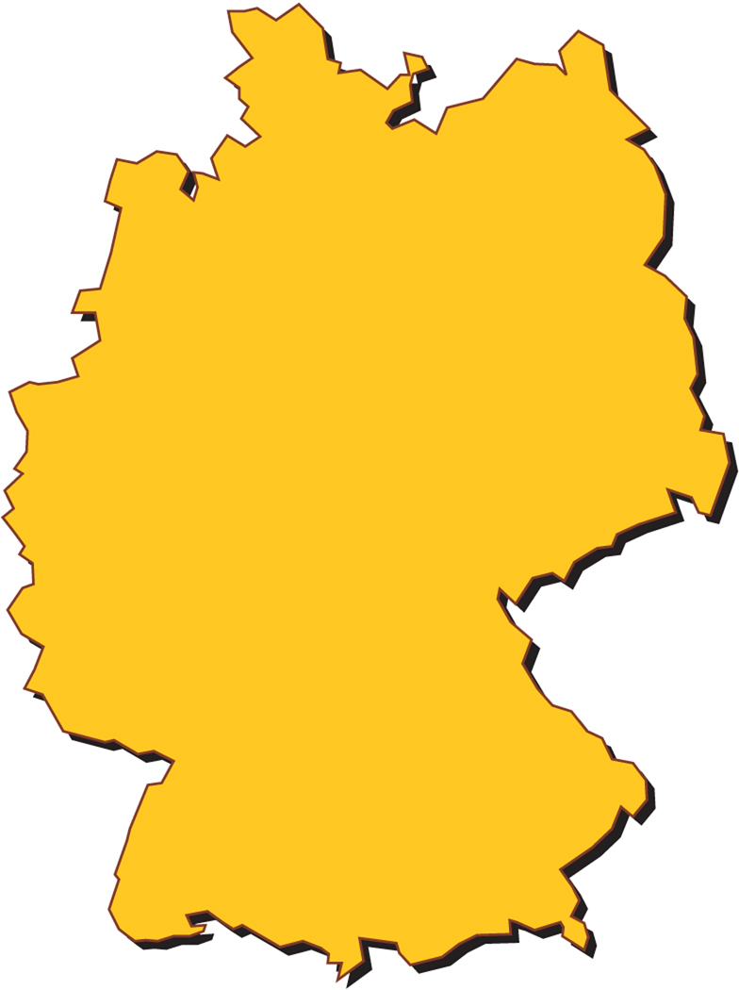
s b n h w s m o u j q y


m u b a y g j w s r f j

