Now you are ready to cast some spells!
Now you are ready to cast some spells!
Decorate your hat with cut out paper shapes.
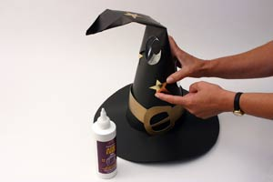

Roll one cardboard sheet into a cone shape. Secure with a small piece of sticky-tape.
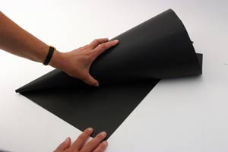

Cut off the excess cardboard so that the cone is even. 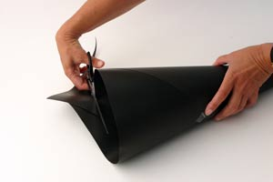
You will need: a piece of black card, tape and decorations.

How to make a wizard hat!

