write a bit…

I’ve used these with the full primary range, and use them to encourage children to think about the steps in writing.. to check for sense.. to ensure that one sentence informs the next.

Hope they’re useful.

write a bit…

read a bit…

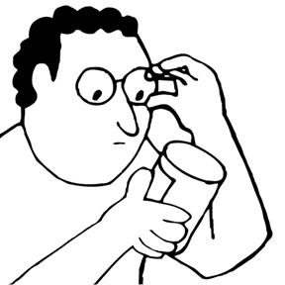
say a bit…

write a bit more…

