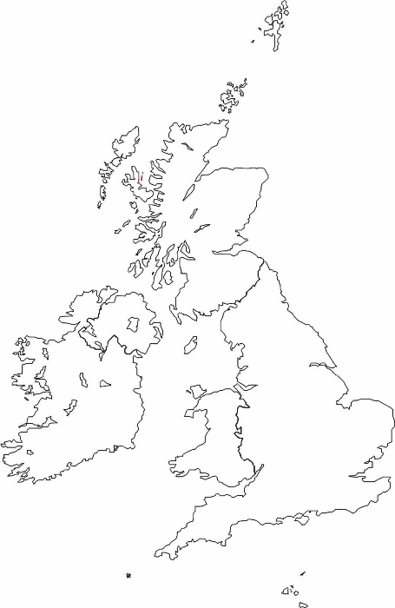
Key:

⁭Scotland
⁮ England
⁭ N. Ireland
⁭ Wales
⁭ Seas and Oceans

