End of topic quiz!
The journey of a river.
A river begins at it’s .
The area drained by a river is called the .
Drainage Basin
Flood Plain
Water Shed
The process of removing material from the banks is called .
Deposition
Erosion
Undercutting
When a river flows over a band of softer rock
overtime it will create a .
A smaller river that feeds the main river is called a .
Tributary
Confluence
Spring
Through a meander the fastest flow is on the
& the slowest flow is on the .
When a smaller meets the main it is called a .
(bonus points if the technical vocab is used in all 3 of these boxes!)

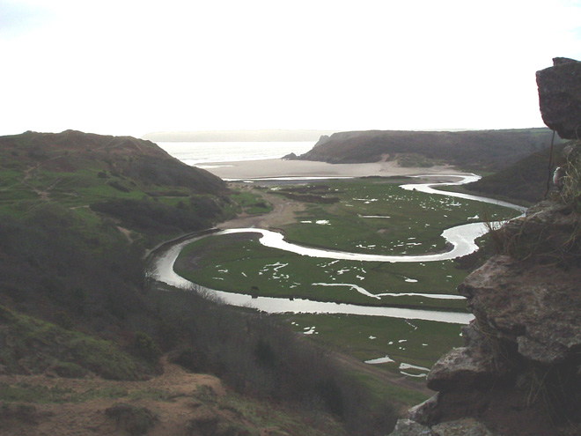
This is a picture of what feature? A .
Overtime the above feature you named will cut through and join
to create an lake.
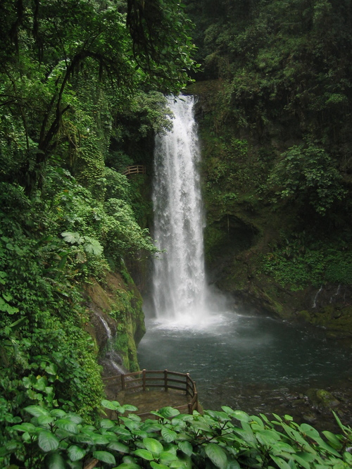
Overtime the above feature will cut backwards to form a narrow .
And finally the river ends at it’s .
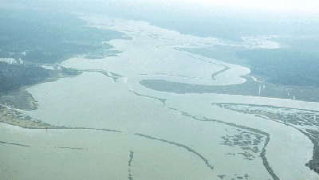
This river is carrying too much water and so has spilled over
covering the .
Drainage Basin
Flood Plain
Wet Land
Beach area

