The United Kingdom

Label the Countries below
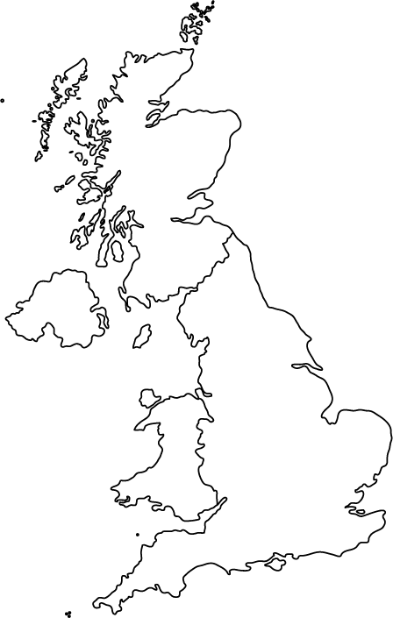

The Countries to be labelled are ….
Northern Ireland, Scotland, England, Wales

