LI: Read the weather forecast for the weather in the UK. Draw the weather symbol and add information to the boxes.
Aberdeen: Cold with rain.
Temperature: 13°C
Belfast: Cold with rain.
Temperature: 13°C
Birmingham: Rain and lightening.
Temperature: 11°C
Edinburgh: cold with snow
Temperature: -1°C
Fishguard: Windy all day.
Temperature: 14°C
London: Warm with sunshine
Temperature: 22°C
Newcastle: Very hot
Temperature: 30°C
Southampton: Very hot.
Temperature: 29°C

Weather Symbols

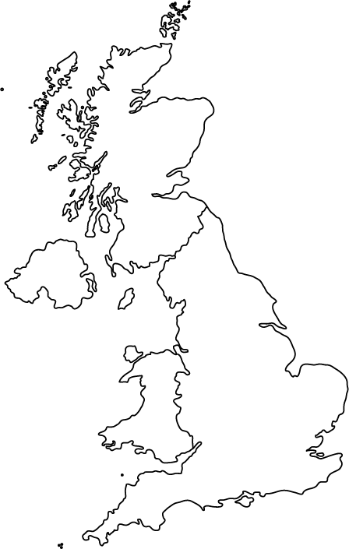
Fishguard
London
Southampton

Birmingham
Edinburgh
Belfast
Newcastle
Aberdeen

Imagine you a weather reporter for the TV station World Wide Weather (WWW). You are in another country giving a weather forecast. What information are you going to give the viewers? Remember, to say:
- Where you reporting from,
- What the weather is like,
- Do you like the weather? If yes, why? If not, why?
- Do the people who live in this country like the weather? If yes, why? If not, why?

create a photograph
of the place you are
reporting from…

