Name _______________________________ Date ____________________________

Barnaby Bear’s home town of Chester

How might you travel from Mill Hill to Chester? ___________________________________________

Near Chester there is a large city called ________________________

Chester is near the country of ______________________

Use the maps and atlases to find Chester, Manchester and London then mark them on the map.

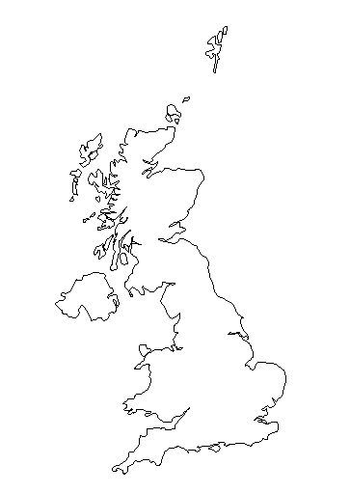

Draw a picture of Eastgate Clock and explain why it is famous.

Draw a pattern that can be fond on the black and white houses. What style are these houses built in?

Who built the wall around the city? ____________________________

What is the name of the shopping Centre in Chester? _______________

__________________________________________________________

There are special shops in Chester called the Rows. Why are they special? ___________________________________________
___________________________________________

When was Chester castle built? _______________________________

What else did you find out about Chester?
_______________________________________________________________________________________________________________________________________________________________________________________________________________________

