EUROPEAN UNION
UNITED KINGDOM OF
GREAT BRITAIN
AND NORTHERN IRELAND

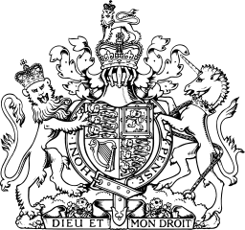

PASSPORT

Her Britannic Majesty’s
Secretary of State
Requests and Requires
in the Name of Her Majesty
all those whom it may concern
to allow the bearer to pass freely
without let or hindrance,
and to afford the bearer
such assistance and protection
as maybe necessary

EUROPEAN UNION
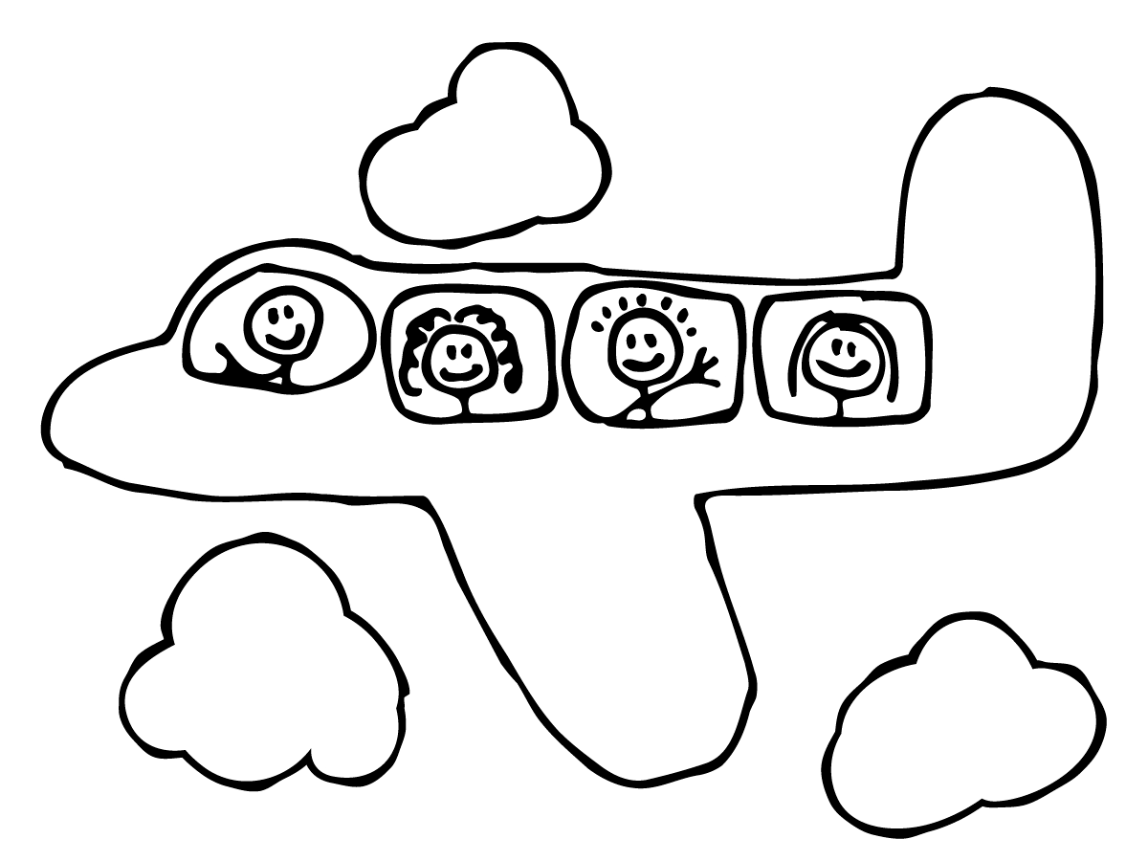
UNITED KINDOM OF GREAT BRITAIN AND NORTHERN IRELAND

PASSPORT

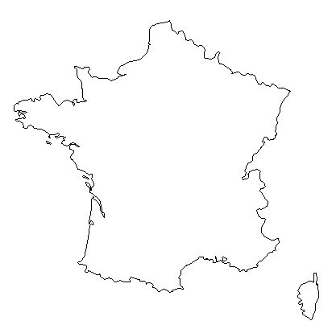
Language:

Flag:

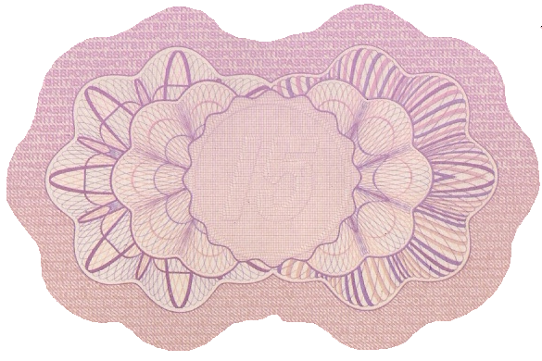
Food:

French Landmark:

france’s Emblem:

Money:

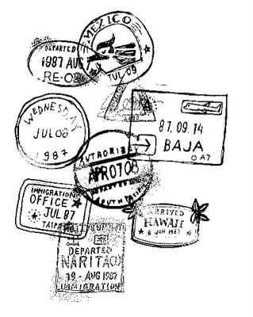

Language:

Flag:

Food:

British Landmark:

Money:

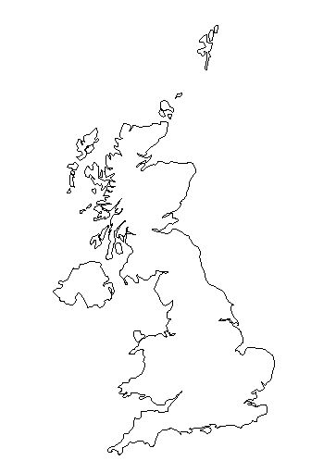

Namibia
Language:

Flag:

Food:

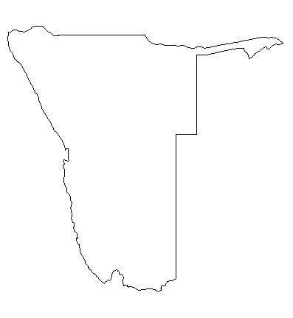
Money:

Namibia’s Emblem:

Australia
Flag:

Language:

Money:

Places:

Animals:

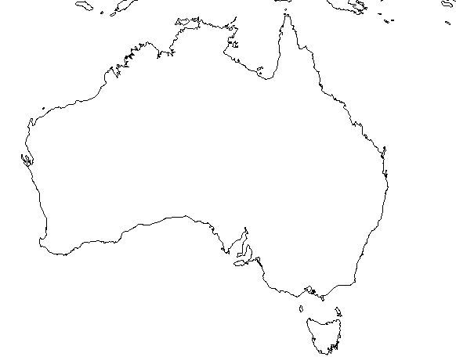
Australia’s Emblem:

Peru
Language:

Flag:

Food:

Places:

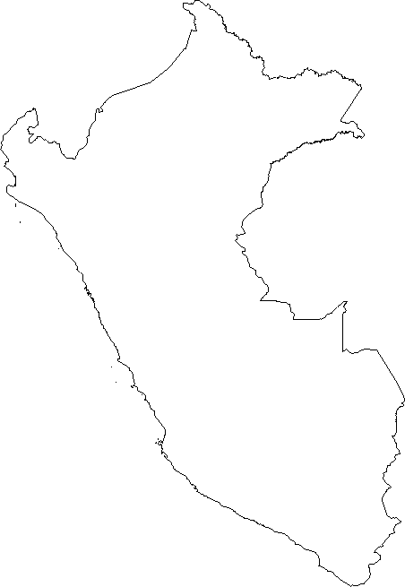
Money:

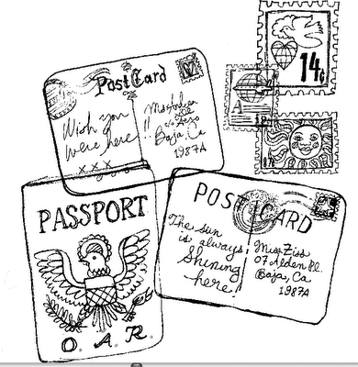
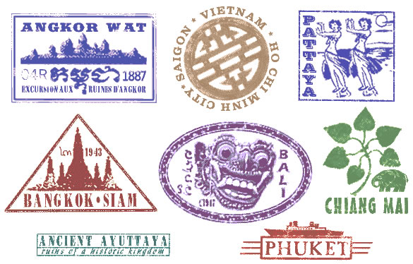
United Kingdom of Great Britain and Northern Ireland
Surname:
First Names:

Nationality:
Date of Birth:
Girl or Boy:
Place of Birth:

PASSPORT

Passport Information:
Name:
Class and School:

Teacher:

Signature:

