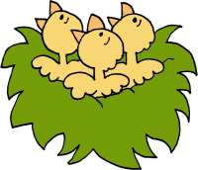
ANIMALS
APRIL
BIRDS
BIRTH
BLOOM
BLOSSOM
BLUE BELLS
BUDS
BULBS
BUTTERFLIES
CHICKENS
CLEANING
CROCUS
CROPS
DAFFODIL
DAY LIGHT
EGGS
EQUINOX
FLOWER BEDS
FLOWERS
FRUITFUL
GARDENING
GREEN
GROW
GROWTH
LIFE
LIGHT
MARCH
MAY
MELTING
NESTS
OUTDOORS
PLANTS
PUDDLES
RABBITS
RAIN
RAINBOW
REBIRTH
REGENERATION
RENEWAL
SEASON
SEEDS
SHOWERS
SPRING
SUNSHINE
THAW
TULIP
WAKE UP
WARMTH
WINDY

L B L M S H E A U O D W K E L D V D G V C R J S U O Y L F U L B G R O F C H B E
H L I Q F L O W E R S P A A A V A N F L D H D U N L S O X K U X E W K N H R N C
K C E R V M L I H D X M W R A P I F E P D U T V A E G I P U F W K O J Q I S D J
Y H J G D P V E H Q S E V J M T F A F U B I W R A O T Q T R T P R F Q B C P V V
L T Q E L S Q Y B C N V Q J L T N T G O Q U M L I R P A L F I U N L U M K O E F
L Z J A Y V J U B E S O X E R I H U O Q D Y F V C B Q W B I U P M U I C E Q Q S
E O N I W N X N R H U H M T N U J P T H G I L Y A D E R A C R U A F E P N N J H
T T V D A O W V M F Q L L G C G A E N J R J L U H E O R I L F M E N E A S C R O
S I N B W A B V A K O F B E H D D W Z S R T G G A W M A M H A S H J I G W Y D W
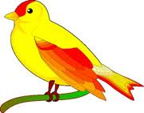
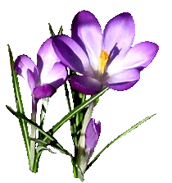
L E Y S J W Q N M S E Y Z W Q V T O C G H D C F O S G O T A T Z B H W M G Y T E
O U T D O O R S I U D V C Y I O H O I M A B B V L M R S G S M L T Y P H A S Y R
U D A E F S V K Q A K G U Y E L O Z K D O Z L F U Y V E E O O O H S M Z X L N S
W I N D Y E F I L D R S V N M Z B J M R L G W N B A Z N G S E T M Y U V B Q S I
F M X G V V K F X B U H I Y E C P R M W N L P M Z P A W S E R C I R M C V S A F
K W F Z E N N I R W B H E A M S E K N J Z X L J W T P O F I N S J I L C O G D A
P M J N O D W D A I S G R O W T H X I Q Z Q H I N O M F B S B E E D D Q B R S T
W G Q X U N G N I N E D R A G B Y V V K T L E Z F O M J B T I L R Z L S D O C V
N F Z S N M R N U U T Z R J X A L I F F T G G Z D D T I U S Y D F A I R Q W D H
R G Z A Z A T S Q F N N H H D C G O K Y T P W K W V P H T K L Z B H T D N L L G
R P G F X T M V L S A Z L N N X V E O J A R H J K W A M T G I T E A W I E S I Q
T H A W K B M O W O Z U Y N Z O N L L M M A K L F C U T E B G G I J A C O X D U
K N G E M Z W X C D D L M P N I L I W T A G J U O T T G R O H V G P K K C N P P
M R M E Y E S O X H M A F I Z U D D V L S B W H L Q K K F E T O M C E Q V D B K
V I C M R S E N Z U R N X L P M D O W D U P B T Y K Z W L A A Y T I U L P E A V
P C U B C T E I C C N O U U K M W R K L Y Y O H T P G T I G O C F H P J H A Q D
T U E I K I D U H B I S S T O D T O B C B V T R K L W X E B G N A X R Q T U A X
G D J C K B S Q S F A A G R E E N S R C F G B M C J Z M S K C S E L D D U P P S
S C H S P B Q E B D R E D C A R U R B G R O E D R Y M Z W G I X K E K L S T F J
B Q D L R A G N I R P S L C N Q D K S F I H X F W G A P T U E W C N A Q A B P H
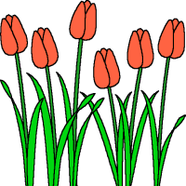

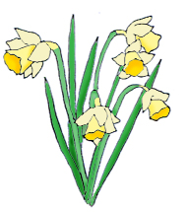
D X T E R R R M Z K L U S U Z G H N O G J G R G I J Y I M O L H N W K W Q K N R
W. Richardson

