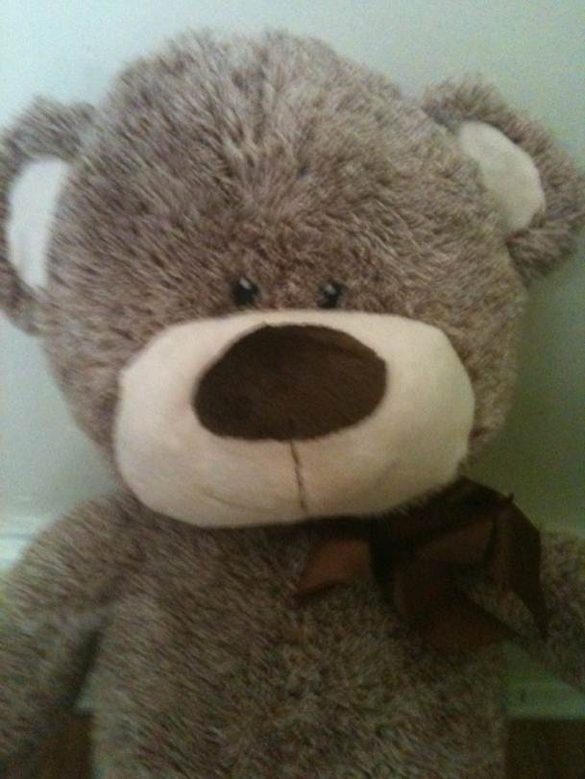
United Kingdom of Great Britain and Northern Ireland
PASSPORT
SURNAME
BEAR
FIRST NAME
COLUMBUS
PLACE OF BIRTH
*** PRIMARY SCHOOL

PASSPORT NUMBER: 00003434

