Which country?

Label the Countries below

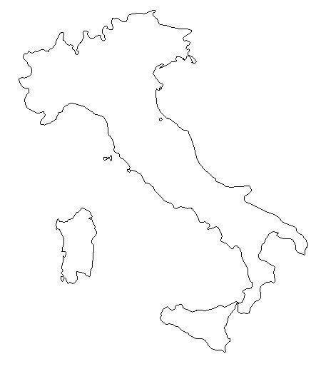
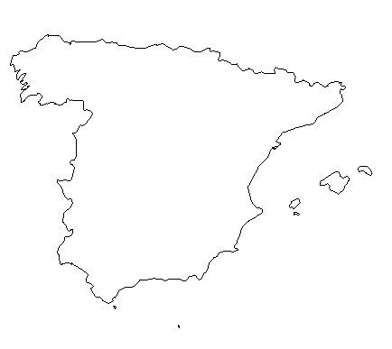
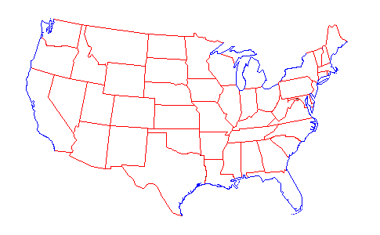
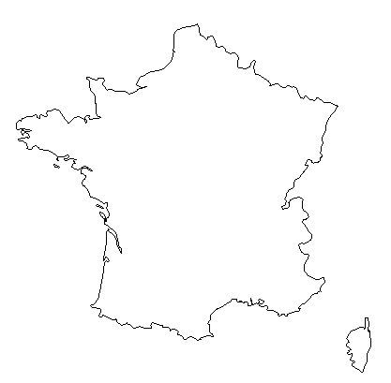
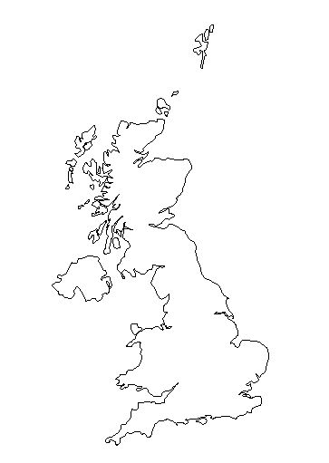
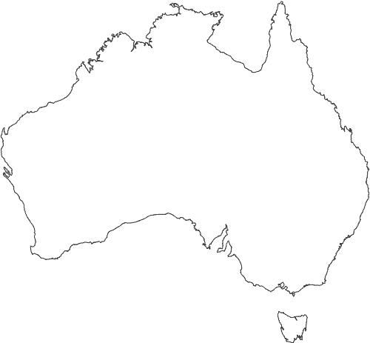
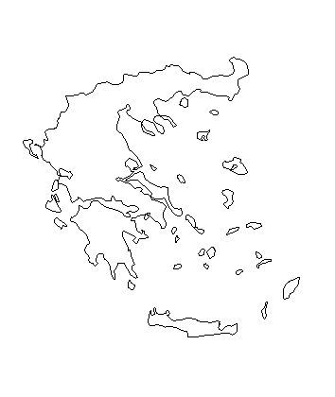
Task 2: Can you match the capital city to each country?

1. Athens:
2. Paris:
3. Rome:
4. London:
5. Washington DC:
6. Canberra:
7. Madrid:
List of countries:

1. United Kingdom
2. France
3. Spain
4. Italy
5. Greece
6. Australia
7. United States of America

