ANCIENT
EGYPT
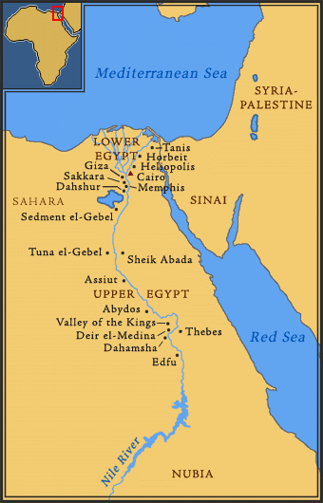
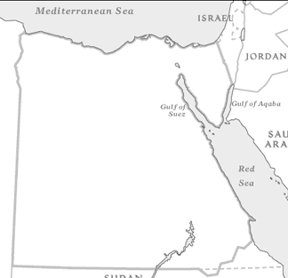
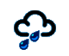



30
40
Egypt is a county on the North Eastern edge of the continent of Africa. It has a border at the ________ Sea and the ___________________ Sea. The border between Egypt and Asia is the Suez Canal.

Egypt is mainly made up of hot deserts. A large river called the River _________ flows through the country into the Mediterranean Sea. This makes the land around the river very fertile so that crops grow well.
Climate
Ancient Egypt would have been a very dry place. There would have been very little rain. It would have been hot during the day and cool at night because there was little or no cloud cover.
Imagine you are an Ancient Egyptian Weather Forecaster; draw the weather symbols onto the map to show the weather for the day.
You will need to add the following onto you map: -

Temperature: ______________

Chances of Rain: ______________

Sunshine: ______________

Cloud Cover: ______________

Wind Speed: ______________

