ANCIENT
EGYPT

Due to the warm weather in Egypt the most popular material for clothing was linen. Linen is a light weight material which keeps the person wearing it cool. Nearly all Egyptian clothes were a spotless white. Sometimes they used dyes to colour the linen red, blue or yellow but coloured or patterned clothes usually meant that the wearer was a foreigner. The Egyptians decorated their clothes with beads and feathers.

Men  The basic items of clothing for men were simple kilts, loin-cloths or tunics.  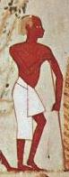 | 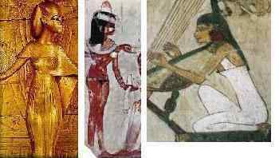  Women  Women wore long, closely-fitting dresses made from fine fabric.

Find out what some of these items of clothing looked like and draw it onto the models below.

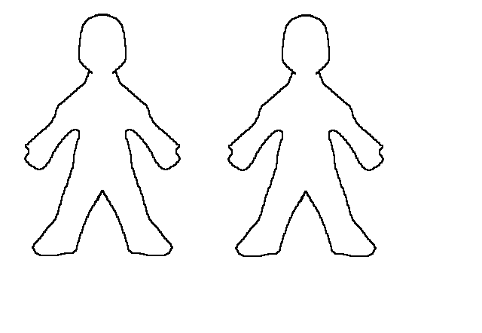

Where did you look to help you draw the clothes onto these models? Make a list below.

