How Britain has changed since 1948
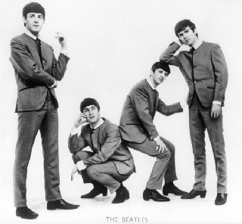

For our history topic, we are trying to find out how various aspects of life have changed since World War II. We would, therefore, be very grateful if you could answer these questions about what life was like when you were around 10 years old.

Don’t worry – all information will be completely anonymous!! No ages revealed!

In which decade were you 10 years old?

Homes and homelife

What kind of a house did you have (detached, terraced etc)
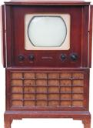

Did your house have central heating?

Did you have an indoor bathroom?

How many televisions did you have in your house?

Did you know lots of people on your road?

What electrical appliances did you have in your house? E.g washing machine, video, dishwasher etc.

What jobs did your parents do?
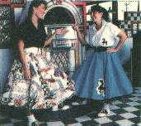

What did you want to be when you grew up?

Spending money

Can you remember how much a chocolate bar would have cost?

Did you used to get pocket money? If so, can you remember how much?

Where did you used to get your weekly groceries shopping from?

Transport

How many cars were there in your household?

How did you used to get to school?

Where did you used to go on holiday?

Pop Culture

What was the first record that you ever bought?

What was your favourite toy when you were a child?

What was your favourite TV programme?

What was your favourite piece of clothing?

Who was your idol?

General

Do you have any other memories that you would like to share with us?

