Hever Castle

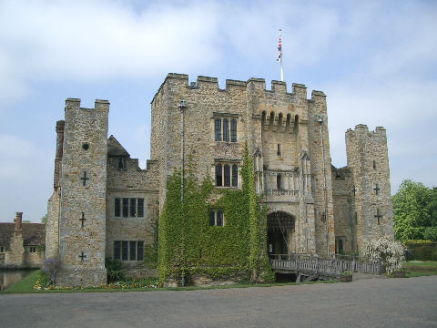

Gardens
- As you walk along the drive you see yew bushes cut into different shapes. What shapes can you see?

- Looking at the front of the castle you can see several different ways in which it could be defended. Name as many as you can.

Castle Courtyard

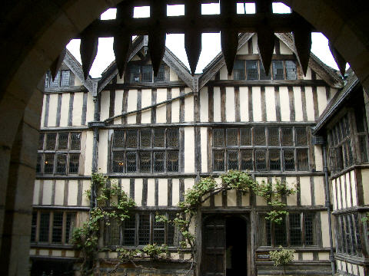

- Which family lived here during the reign of King Henry VIII?

- Which member of the family became famous and what happened to her?

Inner Hall
- The inner hall was the kitchen in Tudor times. Where can you see the Tudor rose emblem?

6. Look at the portraits in the Inner Hall:
(a) Who was Henry’s son? (b) Who was Anne Boleyn’s sister?

Dining Room
- What is the balcony over the doors in the Dining Hall called and what was it used for?

Library
- Look at the ceiling. From which palace is it copied?
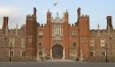
Morning Room
- What are the initials and date on the fireplace in the Morning Room?

Book of Hours Room
- What is a book of hours?
- Who owned the one displayed at Hever Castle?
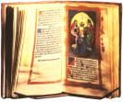

Staircase Gallery
- Compare the two portraits of Elizabeth I.
What differences can you see?

Waldegrave Room
- Why might the small chapel have been hidden behind panelling?

Henry VIII’s Room
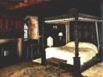

The bed in this room is known as a tester bed.

- What makes this different from an ordinary four-poster bed?

Long Gallery
- What materials are used in the costumes of the figures in the exhibition?
- Are there differences between the clothes of the nobles and the servants?

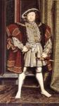

- Name Henry VIII’s six wives in chronological order.

Council Chamber
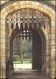

- How can you tell that the Council Chamber is the oldest part of the castle?
- What do the two large weights on the floor do?

Yew Maze
- How old do you think the maze is?

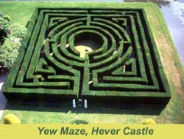

I hope you enjoyed your visit to Hever Castle and will return soon.
Answers!
- The shapes include a snail, butterfly and a corkscrew.
- Moat, portcullis, gates, battlements and arrow slits.
- The Bullen/Boleyn family.
- Anne Boleyn, who was Henry VIII’s 2nd wife. She was later executed for treason in 1536. She had one daughter, Queen Elizabeth I.

- The Tudor rose emblem is on the plaster ceiling.
- (a) Edward VI (b) Mary Bullen.
- Minstrels’ Gallery - where musicians played.
- From Hampton Court Palace.
- HW – this stands for Henry Waldegrave who was a previous owner. The date is 1603.
- A prayer book.
- Anne Boleyn.
- The smaller one shows Princess Elizabeth aged 18, wearing a high ruff. The larger portrait as Queen when she was older, wearing an ornate dress and jewellery, thus fitting her status.

- The owners, the Waldegrave family, were Catholics, and during the reign of Elizabeth I it was illeagal to practise the Catholic religion, so they had a secret chapel built.

- The carved wood back panel and wooden canopy. The thick curtains provided warmth and privacy.

15. Silk, velvet, fur, brocade, cotton and sack cloth.
16. Yes. The rich nobles wore bright, colours, expensive fur and jewels, whereas the poor servants had only cotton or rough sack cloth in dull colours.

17. Catherine of Aragon, Anne Boleyn, Jane Seymour, Anne of Cleeves, Katherine Howard and Catherine Parr.

18. By the thick stonewalls, small windows and garderobe (a medieval toilet).
- The large weights balance the portcullis.
- The maze was constructed in 1904, which makes it 101 years old!

