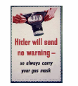

Children in WWII

Evacuation

Rationing

Holocaust
Shelters & the blitz

Daily life
Introduction

Conclusion

