Propaganda Activity
Propaganda – information that is spread for the purpose of promoting some cause.

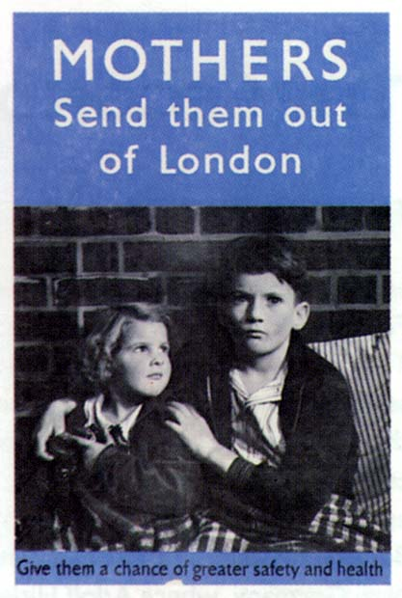

Task – You have been asked by the British Government to design a propaganda poster for evacuation.

Here are some slogans to help you:

- Keep the children in the countryside!

- Keep Britain’s future safe!

- Protect your family – evacuate your children!

- The cities are not safe! Evacuate children now!

- Evacuation is the only way to protect your young!

Remember to make the poster bright and able to grab people’s attention.

