Food was in short supply but the g______________ wanted people to eat h__________ things. Potatoes filled you up so that you didn't feel so h__________, but were healthy too. Potato Pete was a c_________ character who was used on lots of p____________.
Carrots could be __________ in Britain so were not ______________. People thought that eating carrots could help you to see better in the _______________. Carrots could also be used as a _______________.

government hungry healthy posters cartoon
rationed sweetener rationed grown

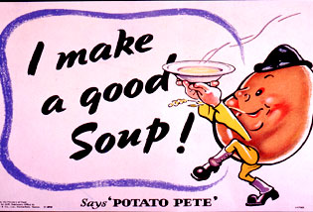
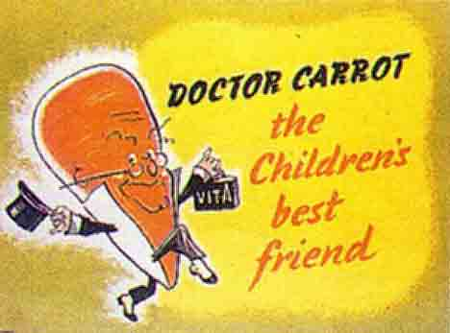

Food was in short supply but the government wanted people to eat healthy things. Potatoes filled you up so that you didn't feel so hungry, but were healthy too. Potato Pete was a cartoon character who was used on lots of posters.
Carrots could be grown in Britain so were not rationed. People thought that eating carrots could help you to see better in the blackout. Carrots could also be used as a sweetner.

The Song of Potato Pete

Potatoes new, potatoes old
Potato (in a salad) cold
Potatoes baked or mashed or fried
Potatoes whole, potato pied
Enjoy them all, including chips
Remembering spuds don’t come in ships.

________________________________________________________________________________________________________________________________________________________________________________________________________________________________________________
________________________________________________________________________________________________________________________________________________________________________________________________________________________________________________

Potato Pete
1. Potato Pete is __________________________________

2. The government made posters to advertise potatoes because ________________________________________
(give 2 reasons)

3. Now either – draw the poster showing Potato Pete, or
- neatly copy the Song of Potato Pete.

Doctor Carrot
1. Carrots were not rationed because __________________
2. People were encouraged to eat carrots because _______________________________________________
(give 2 reasons)
3. Now draw the Doctor Carrot poster on your worksheet.

Potato Pete
1. Potato Pete is __________________________________

2. The government made posters to advertise potatoes because ________________________________________
(give 2 reasons)

3. Now either – draw the poster showing Potato Pete, or
- neatly copy the Song of Potato Pete.

Doctor Carrot
1. Carrots were not rationed because __________________
2. People were encouraged to eat carrots because _______________________________________________
(give 2 reasons)
3. Now draw the Doctor Carrot poster on your worksheet.

