Winston Churchill
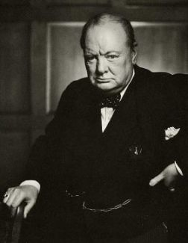
Winston’s Childhood

Life as a young man

WW2

After the war

Adolf Hitler

Adolf Hitler
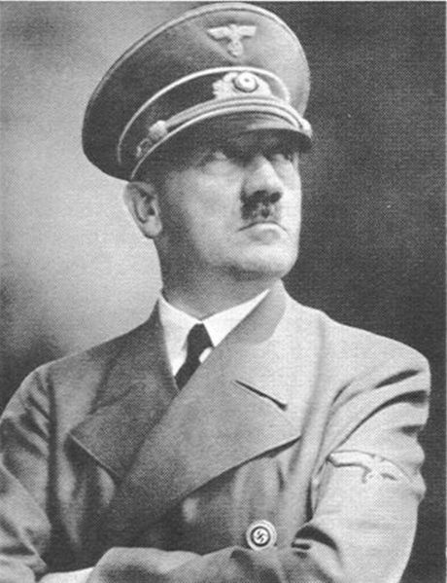
Hitler’s Childhood
Life as a young man during WW1

How he came to power and Started WW2

The Royal Family

The Royal Family
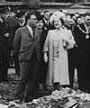

Winston Churchill (Middle ability)

Winston’s Childhood

- Sir Winston Leonard Spencer-Churchill born 30 November 1874
- His father was Lord Randolph Churchill, the third son of the 7th Duke of Marlborough.
- Winston's mother was Lady Randolph Churchill daughter of American millionaire Leonard Jerome.
- He spent much of his childhood at boarding schools.
- He was rarely visited by his mother whom he loved, despite his letters begging her to come and his father wouldn’t let him come home.
- Churchill did badly at school, regularly being punished for poor work and lack of effort.

Life as a Young Man
- He attended the Royal Military Academy Sandhurst. At age 20, Churchill joined the army as a Subaltern of the IV Queen's Own Hussars Cavalry regiment.
- This regiment was stationed in Bangalore, India.
- He fought in many battles including the famous cavalry charge at the battle of Omdurman.
- On 12 September 1908 Churchill married Clementine Hozier
- In 1899 Churchill left the army and decided to become a politician. He stood as a Conservative candidate in Oldham but was not elected.
- Churchill set off as a war correspondent for the Morning Post, receiving £250 a month for four months reporting on the Boer War between Britain and Afrikaners in South Africa
- After returning from South Africa, Churchill again stood as a Conservative party candidate in Oldham in the 1900 general election and was elected.
- In 1911, Churchill became First Lord of the Admiralty, a post he would hold into the First World War.

WW2
- At the outbreak of the Second World War Churchill was again appointed First Lord of the Admiralty, just as he was in the first part of the First World War. The Navy were very pleased about this, they said "Winston's back!"
- At the beginning of the WW2 King George VI asked Churchill to be Prime Minister and to form an all-party government.
- Churchill's speeches were a great inspiration to the people of the United Kingdom during WW2.
- Although Churchill's role in World War II was very important, he had many enemies in his own country.

Life after WW2
- Churchill was heavily defeated in the 1945 election by Clement Attlee and the Labour Party who formed the next government.
- For much of his life, Churchill battled with an illness called depression, which he called his black dog.
- He won the 1953 Nobel Prize in Literature
- On 15 January 1965, Churchill suffered stroke that left him gravely ill. He died nine days later, aged 90, on 24 January 1965.
- As his coffin passed down the Thames on the Havengore, the cranes of London's docklands bowed in salute. The Royal Artillery fired a 19-gun salute (as head of government), and the RAF staged a fly-by of sixteen English Electric Lightning fighters. The state funeral was the largest gathering of dignitaries in Britain as representatives from over 100 countries attended, including French President Charles de Gaulle, Canadian Prime Minister Lester Pearson, Prime Minister of Rhodesia Ian Smith, other heads of state and government, and members of royalty.

Adolf Hitler (Less able)

Hitler’s Childhood
- Adolf Hitler was born on April 20, 1889, at Braunau am Inn in Austria on the border with Germany.
- He was the fourth of six children of Alois Hitler and Klara Pölzl
- There have been rumours that Hitler was one-quarter Jewish and that his grandmother, Maria Schicklgruber, had become pregnant after working as a servant for a Jewish family
- As a young child, Hitler was a good student however in his high school in Linz, His teachers said that he had "no desire to work."
- Hitler later explained this educational slump as a kind of rebellion against his father Alois, who wanted him to have a career as a customs official, although Adolf wanted to become a painter.
- On December 21, 1907, his mother Klara died a painful death from breast cancer at the age of 47

Life as a Young Man
- He wanted to be a painter but the Academy of Arts would not give him a place to study.
- Hitler ran out of money. By 1909, he was living in a homeless shelter, and by the beginning of 1910 was living permanently into a house for poor working men.
- He made money by painting tourist postcards of Vienna scenery. a Jewish man named Hanisch helped him sell his postcards. It was in Vienna that Hitler first started to hate Jewish people.

Hitler’s life during WW1
- Hitler began to claim the Jews were enemies of the Germany people (what he called the Aryan race).
- He helped to establish and was lead the National Socialist German Workers Party, better known as the Nazi Party.
- He blamed Germany's defeat in WW1 and the lack of work in the country on the Jews.
- Hitler fought in France and Belgium in WW1, he acted as a messenger for the regimental headquarters of the 16th Bavarian Reserve Regiment, which meant he had to deliver messages during battles.
- Unlike his fellow soldiers, Hitler never complained about the food or hard conditions, preferring to talk about art or history.
- He received the Iron Cross, Second Class in December 1914 and the Iron Cross, First Class in August 1918, an honour rarely given to a messenger.
- Hitler was unpopular with his comrades because of an uncritical attitude toward officers.

How he came To Power
- After WW1 he became involved with politics and on April 1, 1924 he was arrested for high treason, after trying to take over the country. Hitler was sentenced to five years' imprisonment at Landsberg prison for the crime of conspiracy to commit treason.
- In prison Hitler was treated well by the guards and had much fan mail from admirers.
- Hitler was released in December 1924.

WW2
- The political turning point for Hitler came when the Great Depression hit Germany in 1930 and people began to believe what he said about how t country should be run and that the depression was the fault of the Jewish people who he said were taking the jobs of the German people.
- Hitler became a German citizen until 1932 (the year before he took over Germany).
- On the morning of January 30, 1933, in Hindenburg's office, Adolf Hitler was sworn in as Chancellor during what some observers later described as a brief and simple ceremony.
- He was Chancellor of Germany from 1933, and Führer, the leader of Germany from 1934, until his death.
- He started World War II in Europe by invading Poland.
- In the final days of the war, Hitler committed suicide in his underground bunker in Berlin, together with his new wife, Eva Braun on April 30, 1945.

The Royal Family (More able)

- The members of the Royal family during WW2 were
George VI
His wife Queen Elizabeth
Princess Elizabeth born April 21, 1926
Princess Margaret born August 21, 1930 died February 9, 2002
- On January 20, 1936, King George V died and Prince Edward ascended the throne as Edward VIII. As he had no children ,his brother Albert was now the heir to the throne until the unmarried Edward VIII had any children.
- However, Edward VIII abdicated the throne on December 11, 1936, in order to marry his love, Wallis Warfield Simpson.
- This meant Prince Albert, Duke of York, was now king which he did not want to be because he stuttered and had a nervous disposition,.
- The day before the abdication, he went to London to see his mother Queen Mary. He wrote in his diary 'When I told her what had happened, I broke down and sobbed like a child.'
- 1920 he met Lady Elizabeth Bowes-Lyon, the youngest daughter of Claude Bowes-Lyon, 14th Earl of Strathmore and Kinghorne and decided to marry her.
- The Duke and Duchess of York had two children, Princess Elizabeth (later Queen Elizabeth 2nd) and Princess Margret
- During the war years at first the King and Queen tried to remain friends with Germany and Adolf Hitler.
- They supported the policy of Neville Chamberlain. The King and Queen greeted Chamberlain on his return from negotiating the Munich Agreement in 1938, and invited him to appear on the balcony of Buckingham Palace with them to show their support.
- This made many people angry, including Winston Churchill.
- Some people thought that the King and Queen intended to avoid war with Nazi Germany because they thought it would act as a counterweight against Russian communism.
- When war broke out in 1939, George VI with his wife decided to stay in London and not flee to Canada, as had been suggested.
- The King and Queen officially stayed in Buckingham Palace throughout the war, although they often escaped to Windsor Castle to avoid bombing raids.
- George VI and Queen Elizabeth narrowly avoided death when a lone German bomber dropped a bomb on Buckingham Palace. The bomb exploded in the courtyard, shattering windows in the palace.
- Throughout the war, the King and Queen provided morale-boosting visits throughout the UK, visiting bomb sites and munitions factories.
- It has been alleged that, the royal family ignored wartime rations (although their servants domiciled in the Palace were subject to them).
- Elizabeth was born at 17 Bruton Street in Mayfair, London on 21 April 1926.
- Elizabeth was thirteen years old when World War II broke out.
- She and her younger sister Princess Margaret were evacuated to Windsor Castle, Berkshire.
- There was some suggestion that the princesses be sent to Canada, but their mother refused to consider this, famously saying, "The children could not possibly go without me, I will never leave the King, and the King will never leave his country."
- In 1940 Princess Elizabeth made her first broadcast, addressing other children who had been evacuated.
- In 1945 Princess Elizabeth convinced her father that she should be allowed to contribute directly to the war effort. She joined the Women's Auxiliary Territorial Service (the ATS) where she was known as No 230873 Second Subaltern Elizabeth Windsor, and was trained as a driver.
- This training was the first time she had been taught together with other students. It is said that she greatly enjoyed this and that this experience led her to send her own children to school rather than have them educated at home.
- She was the first and so far only female member of the royal family to actually serve in the armed forces, though other royal women have been given honorary ranks.
- During the V-E Day celebrations in London, she and her sister dressed in ordinary clothing and slipped into the crowd secretly in order to celebrate with everyone without being recognised.
- Queen Elizabeth (our QUEEN’S MOTHER), was the Queen Consort of George VI of the United Kingdom from 1936 until his death in 1952. Elizabeth was the last Queen of Ireland and Empress of India. As Queen Consort.
- Elizabeth was famous for her role in providing moral support to the British public during World War II.
- Adolf Hitler described her as "the most dangerous woman in Europe" because she did so much to keep the British people happy during the war by visiting them and encouraging them.

