Name: ……………………………………………………………… Date:………………………………………………………………

Roman Dinner time
Before the Romans became a huge empire and conquered most of Europe they used to eat very differently to the way they did when they became rich.

During the time that is known as the republic, before they became mighty rulers they used to eat mostly vegetables and ate very simple food. The mother used to make the food or if she was wealthy her female slaves.

But when the Romans grew richer they started to eat all sorts of food that we would find very strange today. In the days known as imperial Rome the rich held huge dinner banquets. Where they would drink lots of wine and eat lots of different courses, a banquet would last for hours.

The food that rich Romans ate were things like stuffed dormice, peacocks, peacocks tongues, little mice, peahens eggs, ostriches, snails, bread and olives. They would eat and eat for hours and hours and often they would go to a room called the vomitorium, make themselves sick so that they could eat more.

This is an example of a Roman recipe:
Baked dormice: "Stuff the dormice with minced pork or the meat of other dormice chopped up with herbs, pepper and pine nuts. Sew up the dormice and cook in a small oven."

Rich Romans liked to show off how rich they were and the more unusual the banquet meal the more it showed their wealth. One recipe was for a chicken to be stuffed inside a duck, the duck inside a pig and then the pig inside a cow and then roasted. This showed the rich Romans guests how wealthy they were.

- Cross off the food that was not eaten by rich Romans.

Chips Peacock
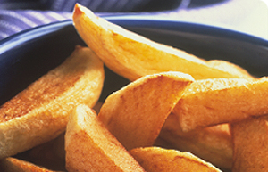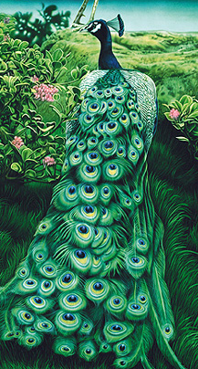

Dormice Jam Mice
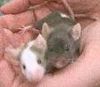

Cheese Bread Olives
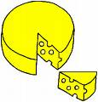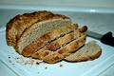

Steak Snails Ostrich
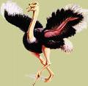

Poor Romans did not eat the same type of food as the rich they would eat a vegetable porridge, when they could afford it they could have fish, bread, olives, wine and sometimes some meat.

2. Write a little account of what you think of the rich Roman’s food.

………………………………………………………………………………………………………………

……………………………………………………………………………………………………………….

………………………………………………………………………………………………………………..

…………………………………………………………………………………………………………………

………………………………………………………………………………………………………………….

…………………………………………………………………………………………………………………..

…………………………………………………………………………………………………………………..

…………………………………………………………………………………………………………………..

………………………………………………………………………………………………………………….
3. Draw a plate of food eaten by poor Romans.

