Neptune
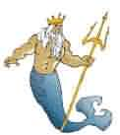
God of the sea
Neptune
God of the sea

Jupiter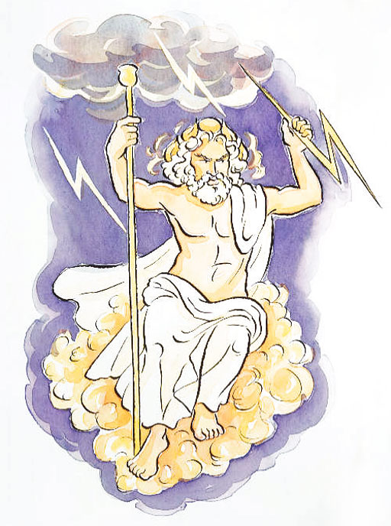
God of the sky
Jupiter
God of the sky

Juno

Goddess of women
Juno

Goddess of women

Mars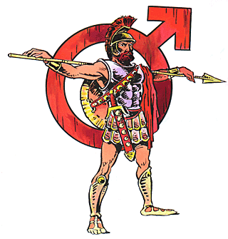
God of war
Mars
God of war

Venus
Goddess of love and beauty
Venus
Goddess of love and beauty

Pluto
God of death

Pluto
God of death

Apollo
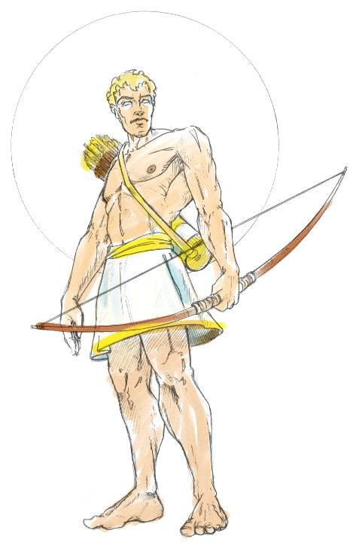
God of the sun
Apollo
God of the sun

Diana 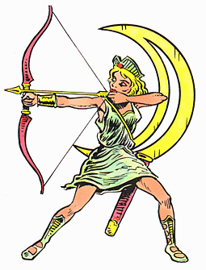
Goddess of the moon
Diana
Goddess of the moon

Cupid

God of love
Cupid
God of love

Mercury 
Messenger of the Gods

Mercury
Messenger of the Gods

Minerva
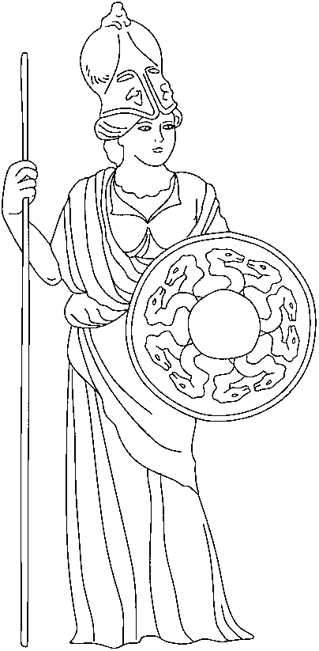
Goddess of wisdom
Minerva
Goddess of wisdom

Ceres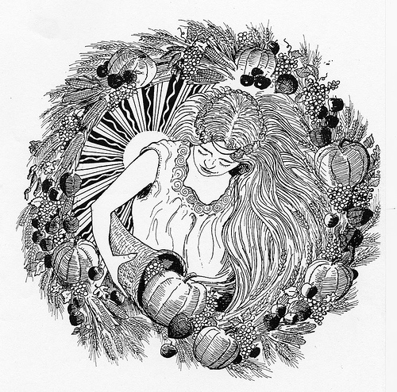
Goddess of the harvest

Ceres
Goddess of the harvest

Bacchus
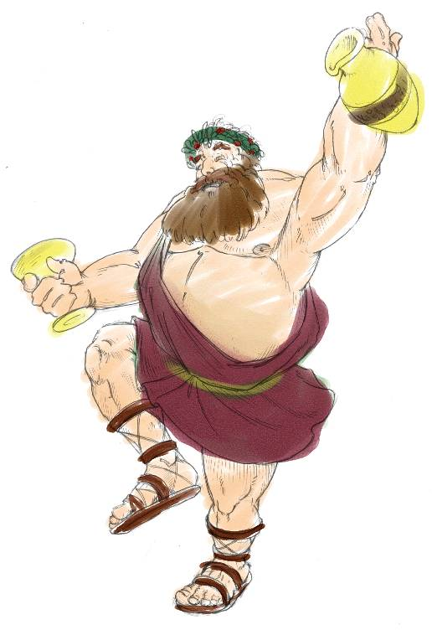
God of wine
Bacchus
God of wine

Saturn

God of time

Saturn
God of time

