Name: _____________________________ Date: _______________________

Diary Entry

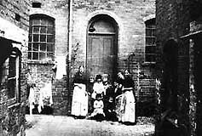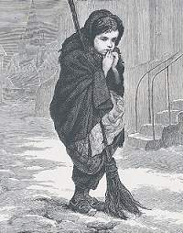

Imagine you are a child in Victorian times. Your task is to write a diary entry about your life.

On Day 1 you should write an account of a working day (e.g. in the mines or in a factory). On Day 2 you should write an account of your life at home.

(Don’t forget to use capital letters, full stops and commas in your writing).
Day 1

I spent much of today in the workhouse. I had to get up _____
_____________________________________________________________________________________________.
The conditions in the workhouse are ___________________
_____________________________________________________________________________________________________________________________________________
______________________________________________.
I felt __________________________________________
______________________________________________.
I was glad when ___________________________________
______________________________________________.
I wish __________________________________________
______________________________________________.
Day 2
Today I stayed at home. The work never ends though! I woke up early and had to ________________________________
_____________________________________________________________________________________________.
Life at home is __________________. I live with my ______
_____________________________________________________________________________________________________________________________________________
We all share a ___________________________________.
We were lucky to have food today. Most of the time I’m hungry. I ate ____________________________________
______________________________________________.
After dinner I went to _____________________________
______________________________________________.
I went to bed early because _________________________
______________________________________________.
I wish we lived like the rich people do. Life would be so much easier then.

_______________________________________________
______________________________________________.
______________________________________________________________________________________________________________________________________________________________________________________________________________________________________________________________________________________________________________________________________________________________________________________________________________________________
________________________________________________________________________________________________________________________________________________________________________________________________________________________________________________________________________________________________________________________________________________________________________________
________________________________________________________________________________________________________________________________________________________________________________________________________________________________________________________________________________________________________________________________________________________________________________
________________________________________________________________________________________________________________________________________________________________________________________________________________________________________________________________________________________________________________________________________________________________________________
________________________________________________________________________________________________________________________________________________________________________________________________________________________________________________________________________________________________________________________________________________________________________________
________________________________________________________________________________________________________________________________________________________________________________________________________________________________________________________________________________________________________________________________________________________________________________
____________________________________________________________________________________________

