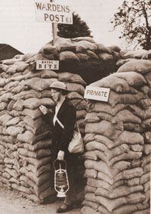  1939  As the air raids started on Britain, wardens were employed to help get people to air raid shelters. | 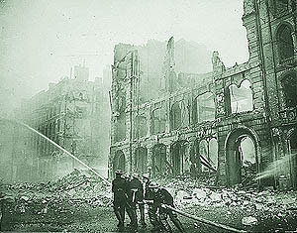  September 1940  London is heavily bombed. | 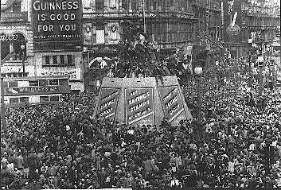  May 8 1945  Germany surrenders.  This is called “V.E.Day”
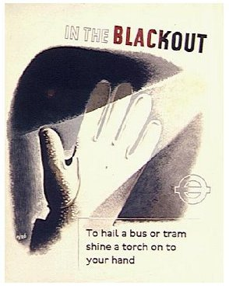  April 1945  The Black Out in London ends. | 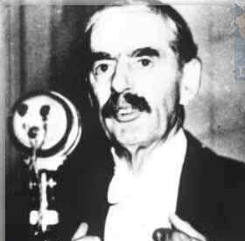  September 3 1939  Neville Chamberlain, the British Prime Minister, declares war on Germany. | 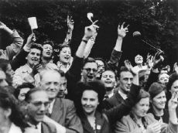  August 25 1944  Paris, the capital of France, is freed from the German troops.
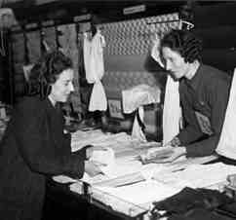  June 2 1941  Clothes rationing begins in Britain as there are no longer enough clothes being produced. | 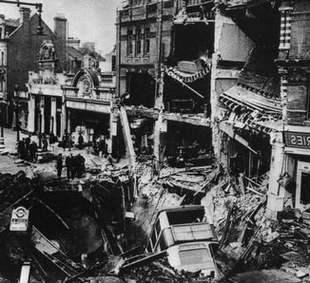  November 1940  There are huge bombing raids on Coventry, Birmingham and Liverpool. | 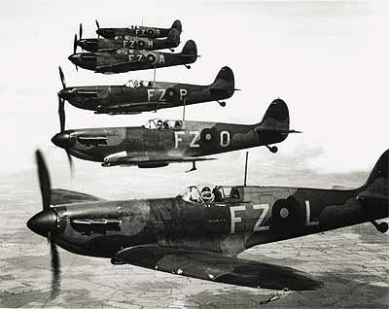  July 10 – September 15 1940  The Battle of Britain, 1,700 German planes are shot down, compared with 900 British planes.
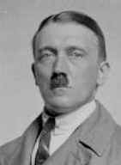  April 1945  Hitler commits suicide. | 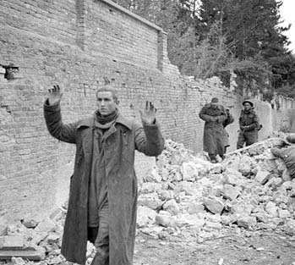  June 22 1941  Germany attacks Russia. | 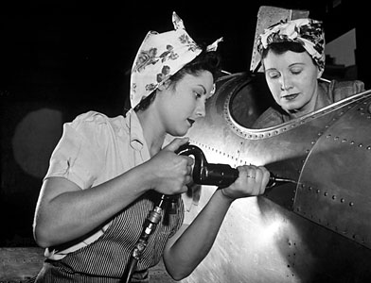  May 3 1943  Part-time work become compulsory for women aged 18-45.
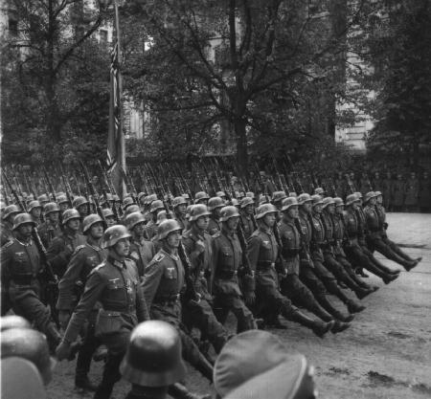  September 1 1939  German troops invade Poland. | 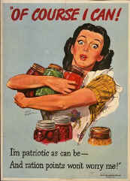  Jan 8 1940  The rationing of butter, bacon and sugar is introduced in Britain. | 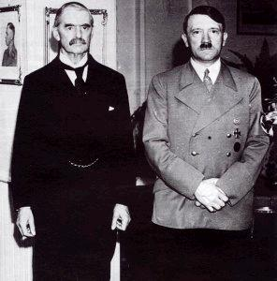  1938  British Prime Minister, Neville Chamberlain, negotiates with Hitler to try to avoid war.
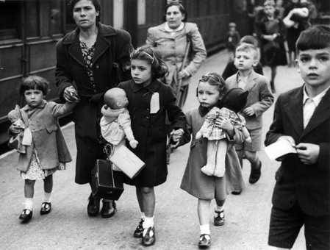  September 1939  In Britain, evacuation of children to safe areas begins. | 1933  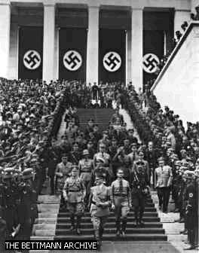  The Nazi Party came to power in Germany. They were led by Adolf Hitler. | 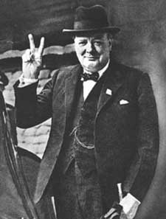  May 11 1940  Winston Churchill becomes Prime Minister of Britain.

