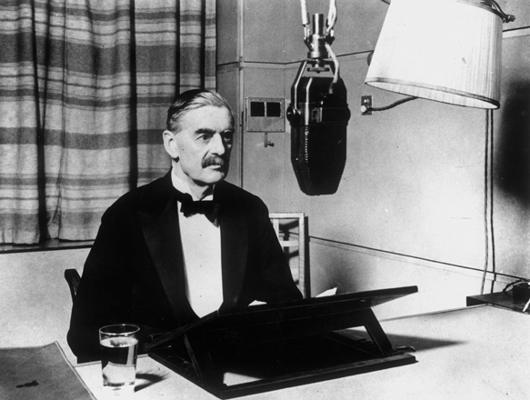

Neville Chamberlain
was Prime Minister
when war broke out
on 3rd September 1939.

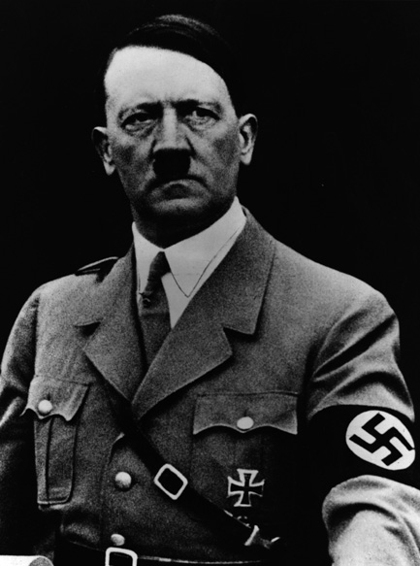

Adolf Hitler was leader of the Nazi party in Germany.

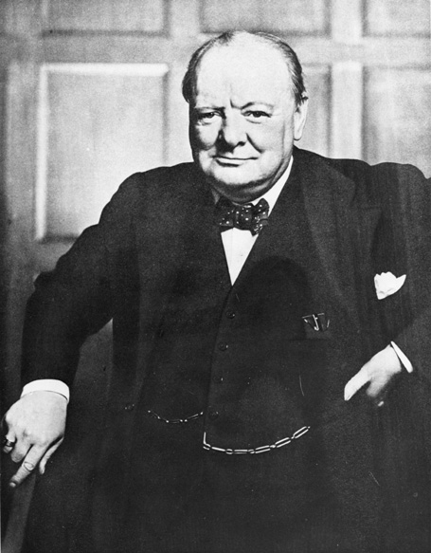

Winston Churchill became Prime Minister in 1940 when Germany was winning the war and people wanted a new, stronger
Prime Minister.

Franklin Roosevelt was president of America.

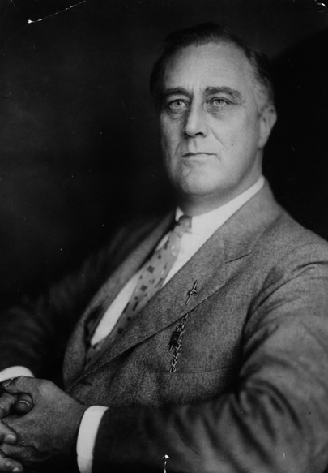

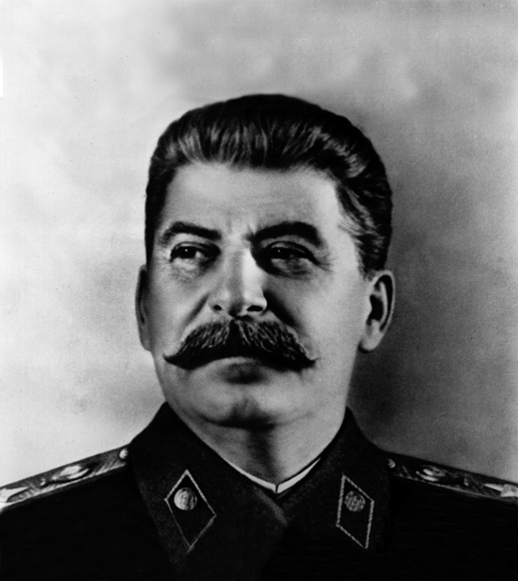

Josef Stalin was president of Russia.
1939

Germany invades Poland

Britain and France declare war on Germany.
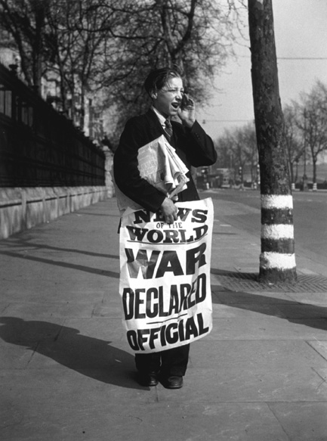

Jewish refugees arrive in Britain.

British school children are evacuated.

1940

The start of rationing.

Winston Churchill becomes Prime Minister.

Dunkirk – 30,000 soldiers are rescued from France.

Germany occupies France and the Channel Islands.

The Battle of Britain is fought in the air.

The Blitz begins – heavy bombing in British cities.
1941

Pearl Harbour – American fleet attacked by the Japanese; America enters the war.

The start of clothes rationing.

Dig for Victory campaign.
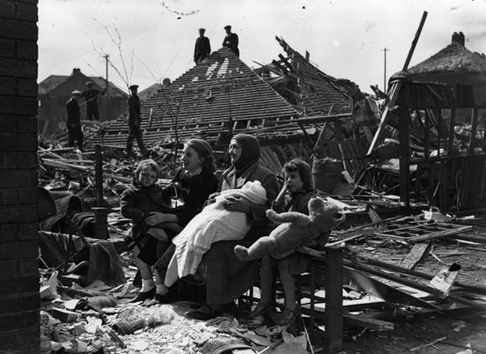

1942

Japan invades Burma.

Germany invades Egypt.

1943

The Allies land in Italy.

1944

D-Day; Allied armies land in France.

The first flying bombs fall in London.
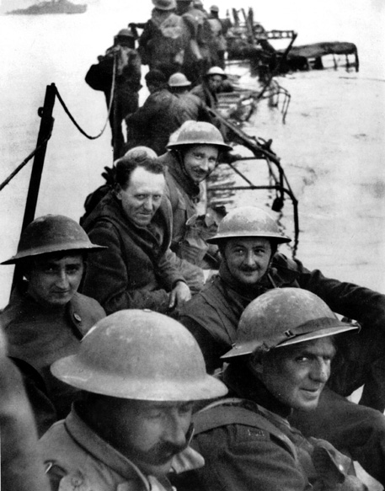

1945

The Russian army enters Berlin; Hitler commits suicide.

Germany surrenders.

VE day street parties take place.
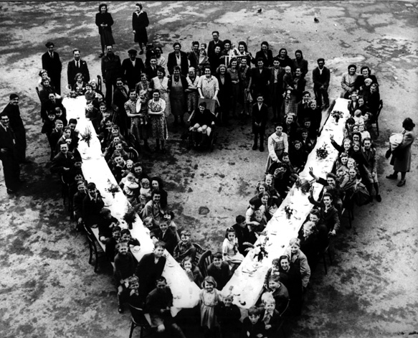

Atomic bombs are dropped on Japan.

Japan surrenders.

VJ day.

Name the leaders - label the photographs and then
add any extra information you have found out.
When did the war begin?

Why did the war begin?

Why was it announced on the radio?

Why is the war always called a World War? _______________________________
________________________________________________________________

1940  Germany occupies France and the Channel Islands. | 1944  D-Day;  Allied armies land in France. | 1942  Japan  invades Burma.
1943  The Allies  land in Italy | 1939  Germany invades Poland and  Britain and France declare war on Germany. | 1945  VE day street parties take place
1940  The Blitz begins – heavy bombing in British cities. | 1945  Japan surrenders.  VJ day | 1941  Pearl Harbour – American fleet attacked by the Japanese; America enters the war
1942  Germany  invades Egypt. | 1940  Dunkirk – 30,000 soldiers are rescued from France. | 1945  The Russian army enters Berlin. Germany  surrenders.

