How An Aztec Sacrifice Happened
The Aztecs were very religious people who believed the world would end if they did not please their gods. The Aztecs believed that one way of pleasing their gods was to offer them human sacrifices.
Human Sacrifices
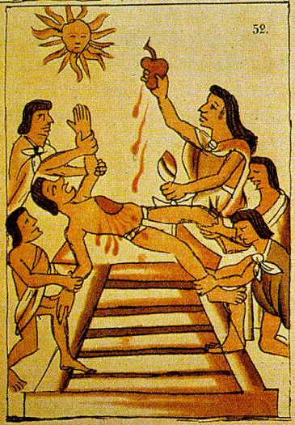
As Aztecs conquered new lands and took prisoners of war, sometimes these prisoners were offered to the gods as human sacrifices. A grand festival would be celebrated at the main temple and the main priest would conduct the loud and lavish ceremony. Human sacrifices were not the only offerings the Aztecs made to their gods. They also presented them with other things they valued, from flowers to beautiful music.
The Aztecs really believed that the sun would only continue to shine if sacrifices were offered to it. To them this was simply following their religion.

How it happened?
On the day of the festival, the unlucky prisoner of war would be woken by guards who would make him drink a strange tasting potion, which would make them feel drowsy. Later they would be led to the temple in the centre of Tenochtitlan. The priests would be present with their bodies painted colourfully and their wild, unkempt hair. Thousands of Aztecs would have gathered to watch the sacrifice and would be chanting, drumming and praying out loud. Then prisoner would be led up the temple steps, and then made to lay down on the sacrificial stone. Using a specially sharp and decorated, obsidian knife the priest would gruesomely behead the prisoner.
More Gruesome Facts
When the prisoner had been sacrificed, the priest would then cut out their heart and raise it high towards the sky to show the gods. This would then be placed in a special container called a Chacmool, as on offering to the gods. Now the head would be displayed on a skull rack with others that had been sacrificed. Then prisoners blood would be poured down the temple steps. Later on, the prisoner’s arms and legs would be eaten by the warrior who captured the prisoner because Aztecs believed this sacrificed flesh to be a holy meal. Nasty!

