The Battle of Bosworth
1. For many years the Lancaster and York families | rose as their badge.
2. Lancaster kings had a | had fought to be the king of England.
3. Yorkist kings had a white | Leicester to fight against Henry.
4. In 1485 King Richard III came to | army at Bosworth.
5. Henry’s soldiers met Richard’s | red rose as their badge.
6. Richard died in the | king after the battle of Bosworth
7. Henry was crowned | battle and was buried in Leicester.
8. The war of the Roses ended when | to make the Tudor Rose
9. The red and white roses were joined together | Tudor king.
10. Henry VII was the first | Henry VII of Lancaster married Elizabeth of York

The Battle of Bosworth

1. For many years the Lancaster and York families | rose as their badge.
2. Lancaster kings had a | had fought to be the king of England.
3. Yorkist kings had a white | Leicester to fight against Henry.
4. In 1485 King Richard III came to | army at Bosworth.
5. Henry’s soldiers met Richard’s | red rose as their badge.

The Battle of Bosworth

King __________III and Henry Tudor fought to be king of _________ at the Battle of __________ . Richard had a white rose as his b________. Henry had a _____ rose as his badge. Richard was killed and Henry became _____. The white and red roses were joined together to make the Tudor ____ .
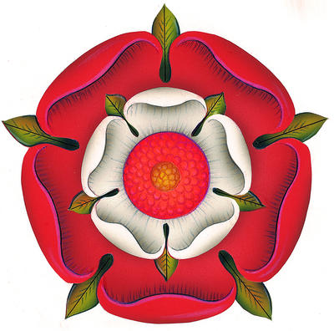
Bosworth
Red
England
King
Richard
Badge
Rose

