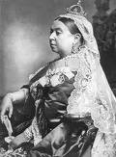
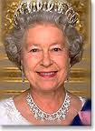

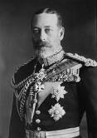

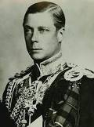

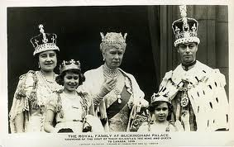

To do your research you will need to use this website:
www.woodlands-junior.kent.sch.uk
http://projectbritain.com/royal/

The Royal Family Today: Family Tree

Queen Elizabeth II
Place photo here
Where does the Queen live?

When did Queen Elizabeth come to the throne?

Who was monarch before her?

Who is the Queen married to?

Why is he a Prince rather than a King?

How many children does the Queen have?

Key words:
Monarch
consort
Prince/ Princess

The next King or Queen
Place photo here
Who is the heir to the throne today?

What is the title of the male heir?

Is the heir always a male?

Who can be heir to the British Throne?

Who cannot be heir?

Who are the four people closest in line of succession to the throne?

Key words
throne
succession
heir

Prince William
Place photo here

Who are Prince William’s parents and sibling?

Who are his cousins?

Where in the order of the line to the throne is he?

What job does he do?

Who is he marrying on April 29th 2011?

Why is this such a special occasion?

Kate Middleton
Place photo here

Where did Prince William and Catherine Middleton meet?

Is Catherine royal, a Princess or Lady?

Why is it unusual for Prince William to not marry someone with a title?

Key words:
title
commoner

The Royal Coat of Arms
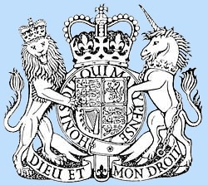

What are the animals on the left and right holding the shield?

Why is the unicorn chained?

What does DIEU ET MON DROIT mean?

Which language is it written in?

Where might you see this coat of arms?

Queen Victoria
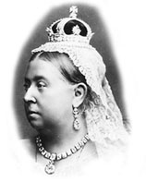

Queen Victoria is the longest reigning monarch
in UK history.
Queen Victoria was only 18 when she came to the throne and she had a lot to learn. Her reign had a rocky start. She thought that, as queen, she could do as she liked, and she quickly had to learn that she couldn't.
Queen Victoria's reign spanned sixty four years, from 1837 - 1901.
When was Queen Victoria born?

Where was Queen Victoria born?

What name was she christened as?

When did Victoria become Queen?

Who did Queen Victoria marry and when?

How long exactly did Queen Victoria reign?

Why did Queen Victoria wear black?

What were her children called?

How many did she have?

Become an expert!
Using the Woodlands wWeb pages on the British Royal family, now do your own research about a British King or Queen. Invent some questions of your own, the answers to which you could find out on these pages and create your own pages with information and pictures. Don’t forget to write the information in your own words after you have read it thoroughly yourself.

