Copy:
Dangerous Tudor Travel

Tudor roads were very dangerous to travel on. A highwayman would rob travellers. They would steal their money and jewellery. At night the roads were dark because there were no street lights. Dirty water and rubbish were thrown onto the streets. Many people got ill and died.

Stick in your book:
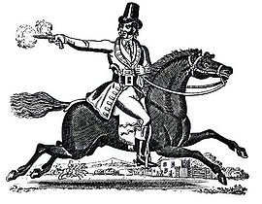
Dangerous Tudor Travel

Highwaymen
A highwayman would rob __________. The passengers would have to give the highwaymen their jewellery and ________.

Accidents
At night the roads were dark because there were no street ___________. In London you could hire a ___________ with a lamp to light your way.

Sickness
Dirty __________ and other rubbish were thrown onto the streets. Many people caught __________.

Uncomfortable
The rich people rode in _____________. They were very uncomfortable because they did not have __________ and roads were very bumpy.

water lights travellers springs

money carriages linkboy diseases

Dangerous Tudor Travel

Highwaymen
A highwayman would rob __________. They would hide on lonely roads on horseback. They would then stop a passing ________. The passengers would have to give the highwaymen their _________ and money.

Accidents
At night the roads were dark because there were no street _______. In London you could hire a ________ with a lamp to light your way. Many people avoided going out after dark.

Sickness
Roads had no drains. Dirty ________ and other rubbish were thrown onto the streets. Many people caught diseases. Cholera, __________, smallpox and measles were the worst diseases.

Uncomfortable
The _______ people rode in carriages. They must have been very uncomfortable because they did not have _________ and roads were very bumpy.

linkboy rich jewellery springs water

travellers plague carriage lights
______________________________________________________

