- Who did Catherine of Aragon marry first? _________

Henry's Wives Quiz
- How old was Henry when he and Catherine got engaged? ___________
- In what year did Henry marry Anne Boleyn?_______
- What was the name of Anne Boleyn’s daughter? _________
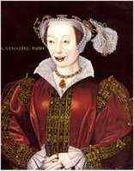
- How did Anne Boleyn die? ______________________
- What was the name of Henry’s third wife? _________
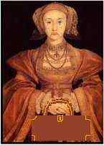
- What was the name of her son, born in 1537? _______
- How long did the marriage to Anne of Cleves last? __________
- What relation was Katherine Howard to Anne Boleyn? ___________________
- How old was Henry when he married Katherine Howard? ______________
- In what year did Henry order Katherine Parr’s head to be cut off? ______________
- Who was Katherine Parr really in love with? _____________
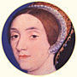
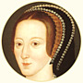
- In what year did King Henry VIII die? ________
- In what year did Kathryn Parr die? _________
- How did Kathryn Parr die? __________________________________________
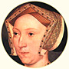
List Henry VIII six wives in order:
Wife Number: | Wife Name: | What happened?
1st wife
2nd wife
3rd wife
4th wife
5th wife
6th wife
Visit website: www.brims.co.uk/tudors/wives
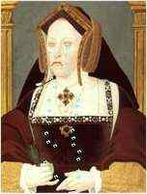
to find the answers!

