The Mechanics of Ancient Greece

Design Technolgy Project

Task 1

Design a lever system to lift a large rock or stone onto a vehicle for transporting to the temple

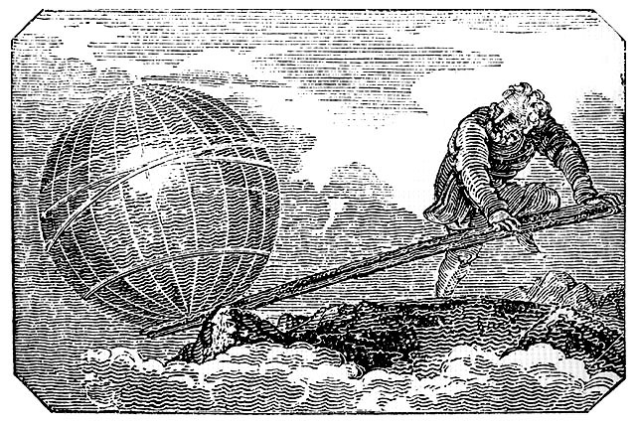

Task 2

Design a mechanism based on the Archimedes claw to put the rock or stone into place on the temple walls

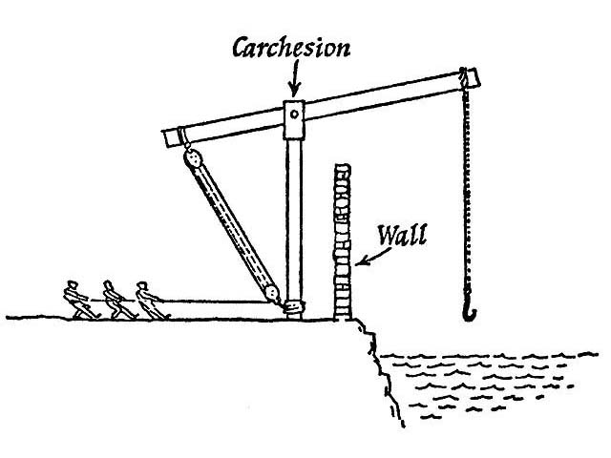

A few questions to think about
- What materials will be suitable in your scale model?
- How will you stop the brick rolling back when pushing it up hill?
- How will you create enough force to lift the brick?
- Will your device be mobile? Does it need to be?

A few questions to think about
- What materials will be suitable in your scale model?
- What will you use as your base to carry the stone into position?
- How will you create enough force to lift and control the stone?
- Will your device be mobile? Does it need to be?
"Give me a place to stand on, and I can move the earth."

Archimedes

