Rationing it out (1)

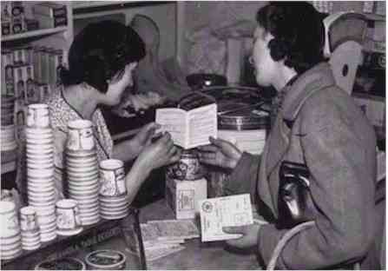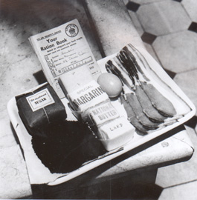
Food rationing came into force in January 1940. At its worst, in 1942, a typical ration for one adult per week was:
Butter: 50g (2oz) | Bacon and ham: 100g (4oz) | Margarine: 100g (4oz)
Sugar: 225g (8oz). | Meat: To the value of 1s.2d (one shilling and sixpence per week. That is about 6p today) | Milk: 1800ml (3 pints) occasionally dropping to 1200ml (2 pints).
Cheese: 50g (2oz) | Eggs: 1 fresh egg a week. | Tea: 50g (2oz).
Jam: 450g (1lb) every two months. | Dried eggs 1 packet every four weeks. | Sweets: 350g (12oz) every four weeks

Foods such as rice, jam, biscuits, tinned food and dried fruit were rationed by points.

Each family had to register with a shop or store where the food would be bought and this was the only place where the family could shop. Each member of the family had his/her own ration book, adults had a buff coloured book, children over three had a blue book and babies had a green book.

How much food would your family be able to buy each week?
Count the number of people in your family who live in your house, adults and children, and calculate how much of each food item you would get.
Write the answer in grams and kilograms
e.g. In my family there are 5 people, so:

butter 50g 5 x 50g = 250g = 0.25kg
Rationing it out (2)

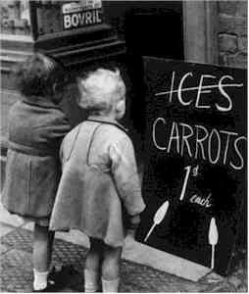

Planning a World War II Food Rationing Menu
1. Look at the different food groups in the rations. What do you notice? Are all the food groups represented in the weekly ration? Why do you think these foods were chosen? Vegetables and fruit were not rationed, why? Bread was not part of the weekly ration, why?

2. Plan a week-long menu using foods that were rationed in World War II.
First, look through some of the authentic recipes to give you some ideas.
You will plan breakfast, lunch and dinner for a seven day period. Meals should be nutritious. You may use the food guide pyramid to help plan healthy meals.
Any unrationed foods can freely be added to the menu, such as fresh fruits or vegetables that are homegrown in a victory garden.
Put your family’s rations in this box to help you:
Butter: | Bacon and ham: | Margarine:
Sugar: | Meat: | Milk:
Cheese: | Eggs: | Tea:
Jam: | Dried eggs 1 packet every four weeks. | Sweets:

