2010 AD
Today
1666 AD –Great
Fire of London
1066 – William invades England from France
409 AD - The Romans leave Britain
43 AD – Romans invade Britain and stay
1066 AD
0 - Jesus is born in Bethlehem
0 -

Name:…………………………………..
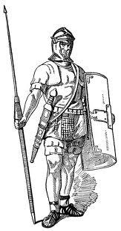

409 AD -

0 500 1000 1500 2000

2010 AD
1666AD
43 AD –

- -Cut out the labels and stick on the timeline - - - - - - - - - - - - - - - - - - - - - - - - - - - - - - - - - - - - - - - - - - - - - - - - - - - - - - - - - - - - - - - - - -

