True or False? Copy the true statements in to your books

The Romans came from Rome.
The Romans came from England.

The Celts liked the Romans.
The Celts did not like the Romans at all.

The Romans used shields in battles.
The Romans used sticks in battles.

The Celts beat the Romans at Maiden Castle.
The Romans beat the Celts at Maiden Castle.

The Roman army was very good at fighting
The Roman army always lost battles.

Draw these battle objects in your book and label them

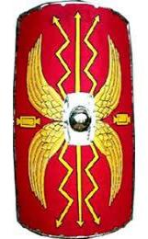
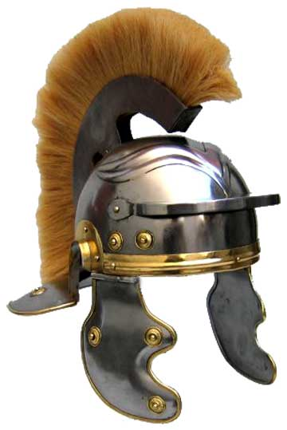
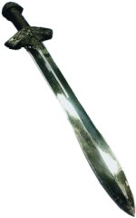
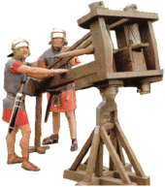

Object Names:

Shield Balista Sword Helmet

