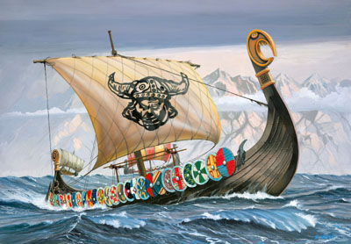

Vikings invade Britain 793AD
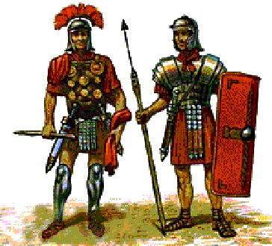
Romans arrive in Britain in 43AD
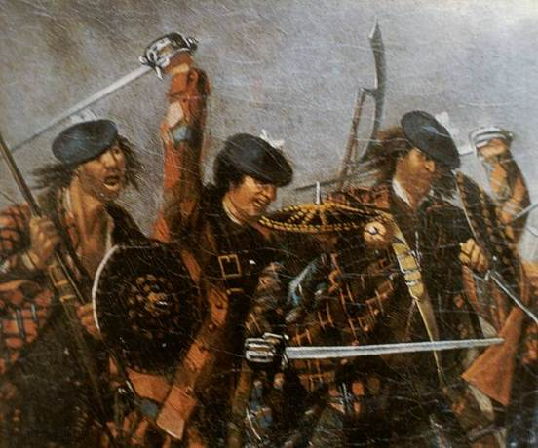

Jacobites: The 1745 Rebellion
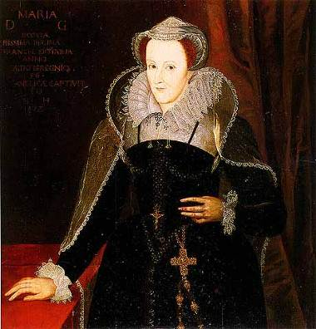
Mary Queen of Scots born in Linlithgow Palace in 1542
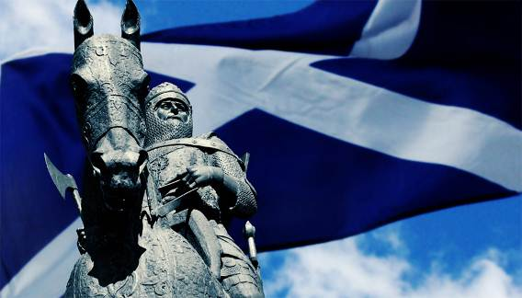
Scottish Wars of Independence 1286-1328
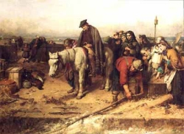

The Highland Clearances 1785
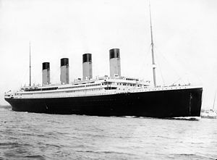

The Titanic sank on the 15th April 1912
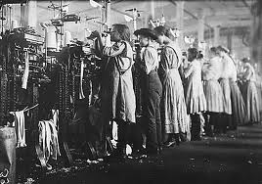

The Industrial Revolution 1800’s
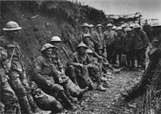
World War I 1914-18
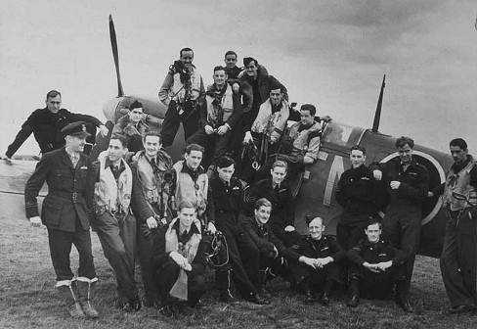

World War II 1939-45
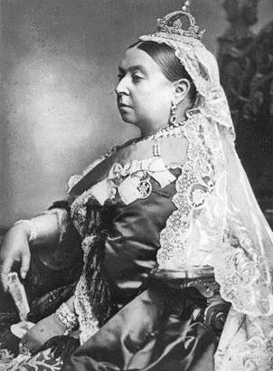
The Victorians 1837

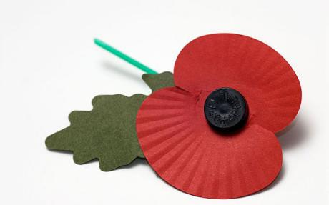
Remembrance Day
11th Of November 1919
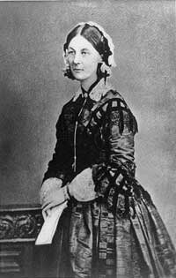

Florence Nightingale
12 May 1820
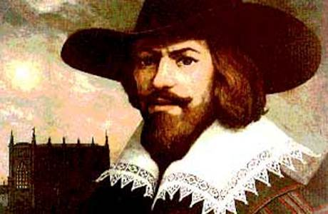
Guy Fawkes
November 5th 1605
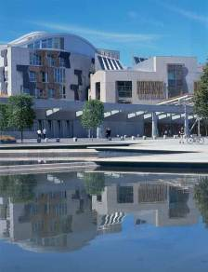
1999- The first Scottish Parliament election.
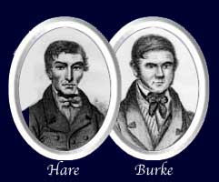

Burke and Hare
1827
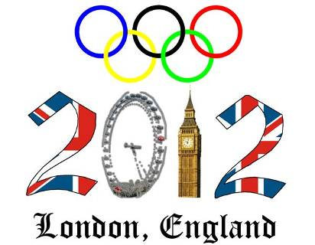
Olympic Games 27th July 2012
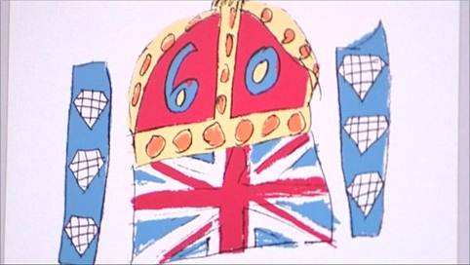

Queen’s Diamond Jubilee
5th June 2012
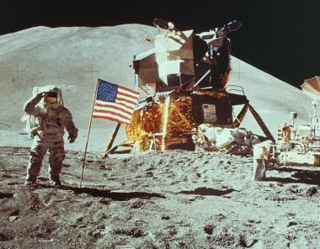

Moon Landing
21st July 1969
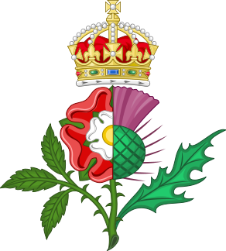
Union of the Crowns
1707

