1297
The battle of Stirling
Bridge
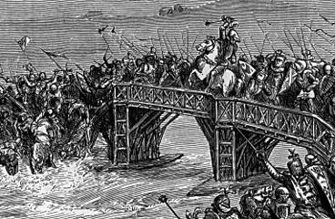
1286
King Alexander III dies
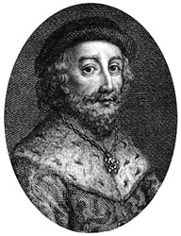
1292
John Balliol is crowned King of Scotland
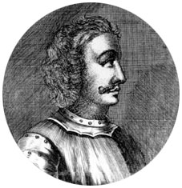
1290
The maid of Norway dies.

1298
The Battle of Falkirk.

1305
Wallace is captured and executed.
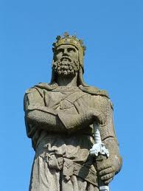
1306
Robert the Bruce is crowned King of Scotland.

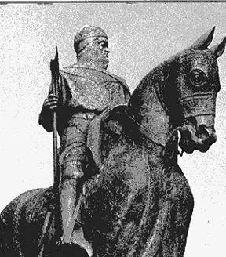

1314
The
Battle of Bannockburn

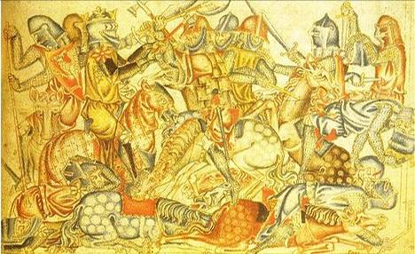
1320
The declaration of
Arbroath.

