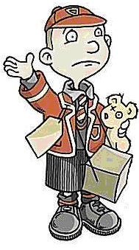

Match the items to the correct suitcase…

1 vest 2 pairs of stockings overcoat or mackintosh dry biscuits 1 slip towel

boots or shoes toothbrush 1 cardigan 1 pair of pants 1 blouse 1 petticoat

1 pair of trousers handkerchiefs 2 pairs of socks 1 pullover or jersey plimsolls

1 pair of knickers packets of nuts and seedless raisins face-cloth soap sandwiches

barley sugar comb barley apple orange

BOYS

GIRLS

BOTH

