Punishments
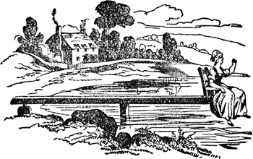
- Ducking Stool
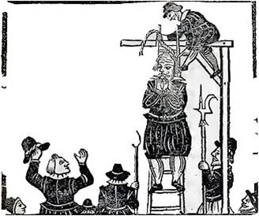

- Hanging
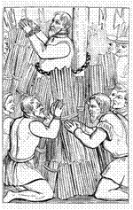

- Burnt at the stake

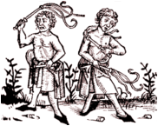
- Flogging
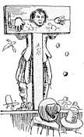

- Locked in the pillory

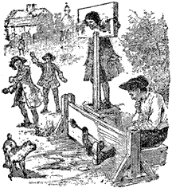
- Locked in the stocks
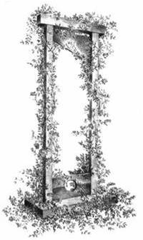

- Beheaded

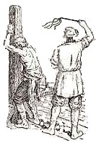
- Whipping
Crimes

- Begging in the street

- Witchcraft

- Selling rotten food

- Being dishonest

- Stealing and murder

- Robbery

- Speaking out against the Monarchy

- Speaking out against the Church

Match the punishments with the crimes.

